SO we choose Sales button

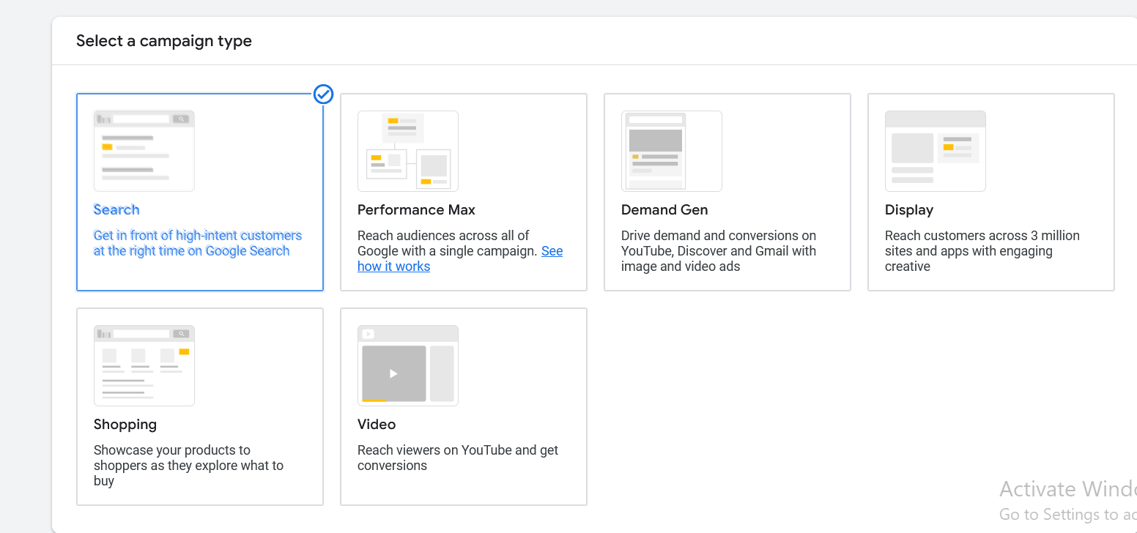

And now below it choose Search in campaign type

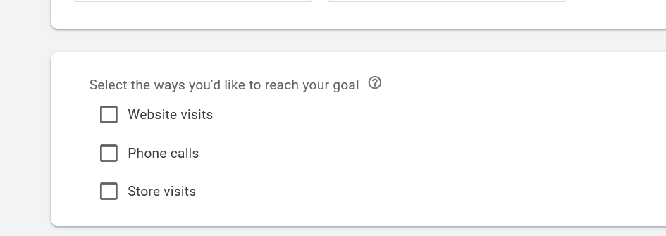Now select the ways you’d like to reach your goal

Here we choose Website visits

I think it tell what the link will do when clicked on it

For now we are understanding search campaign in future we are going to understand multiple campaign type

Mostly option will repeat again and again in different campaign so what he will topd us here will not repeat it

So make sure to understand properly and we will move fast forward so that we will not repeat the option and waste the time

So now after click Website visit

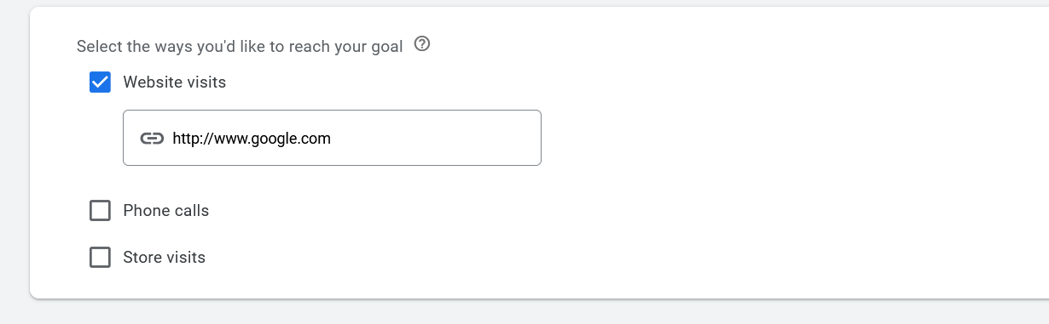

It will ask you your link

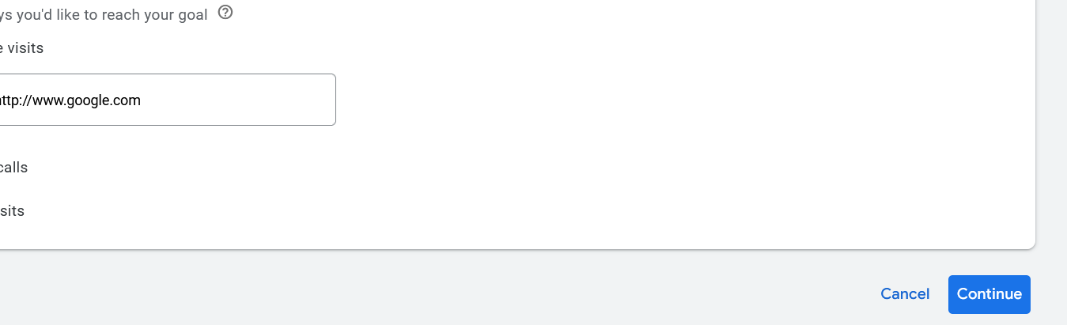

Now click on continue button

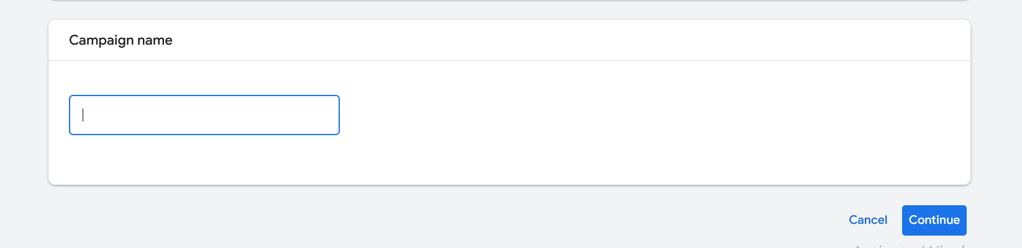

Now it will be expanded now name the campaign you can tell what work it does and name it such that you will remember later

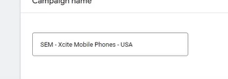

Teacher name it as shown above

Now click on next button

And now Next option we get of bidding

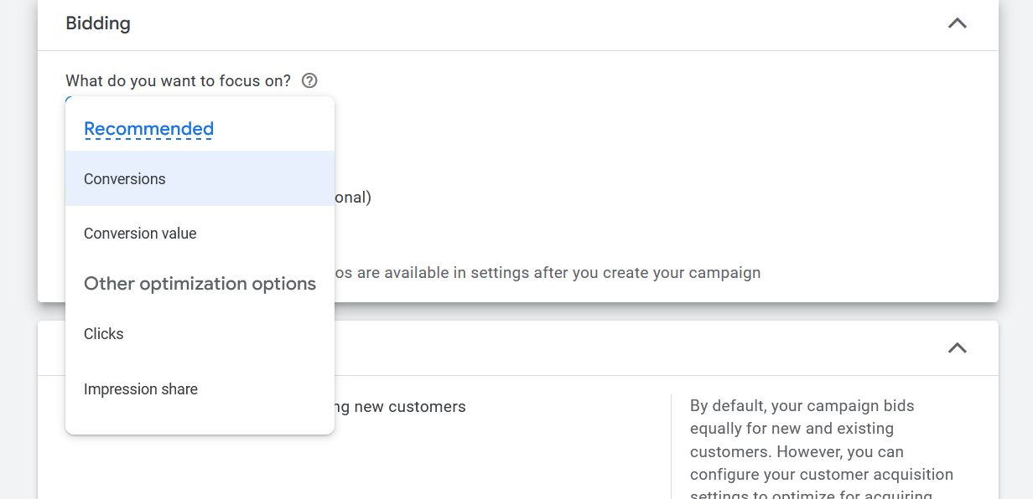

By clicking on bidding field then the submenu will be opened and the above option will be shown

I think here we tell for what type of people we want to show the ad to and for whom we want to bid for

TO whom who will definitely converge

There are many opthers option which you wil see after the campaign is created

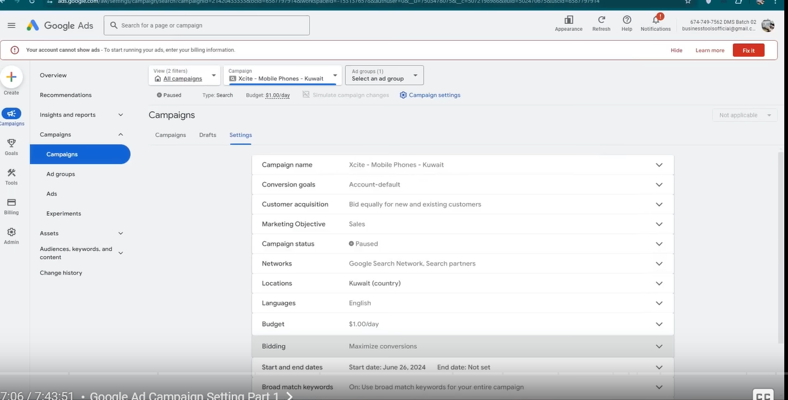

I think that’s how the Campaign setting will look like

And I also think the more account becomes old the more option he get for bidding

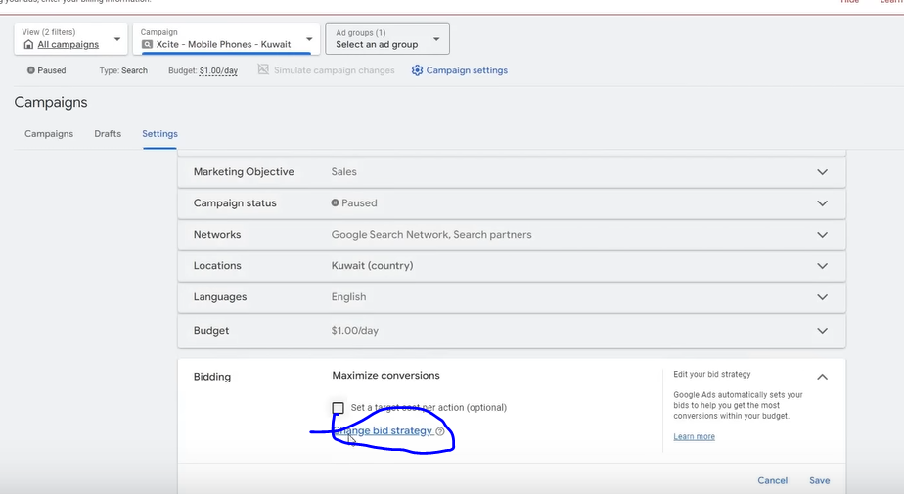

In setting go to bidding and then click choose a bidding strategy as marked above

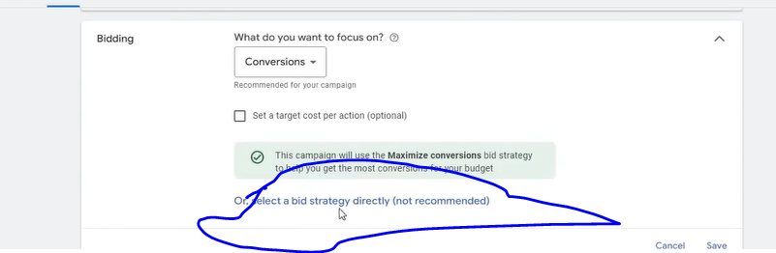

Now click on the above marked area

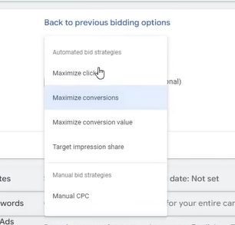

Now above you see all the options of bidding may be they are the more detailed version of the bidding oiption we see

Since we are talking about search campaign

There are more bidding which we will talk later

So first we see maximize click

Her you are saying that you want more and more click whatever its quality (who knows)

Conversion does not matter

It means google will optimize for the click

You can get conversions but it mostly optimize ads for more click

These bidding strategies are divided into Automated bidding strategy and Manual Bidding strategy

In manual we have manual CPC and in automated are others

Now in Maximum Convergence we are saying to oogle that in our budget we need more and more convergence

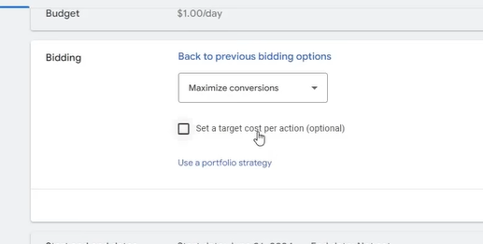

Now we check the checkbox Set a target cost per action

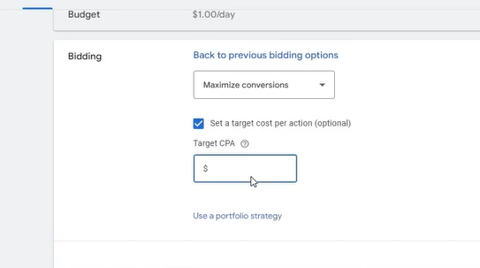

Here you can tell CPA

NOw in context of maximum convergence

Here we give cost per convergence target

Mean if we are entering an amount here then we are giving the target to google here that we want a convergence within this budget Suppose if we are putting 50 dollar then it means we are saying we want convergence in 50 dollars

How to use it we will see it later

Now in Maximize convergence value we tell that we want to optimize out ad according to the maximized revenue

Here maximum convergence value mean want more and more revenue

In maximize convergence the focus will be on selling more and more products but in maximum convergence value our focus will be that product which is costly will be purchased

**Phase 5**

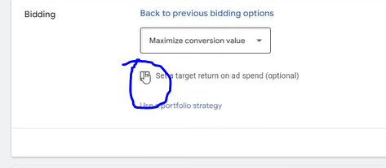

Now check the above marked area

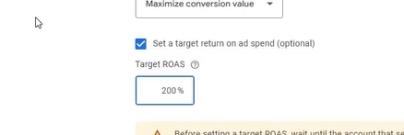

Now we get ROAS

Basically it tells what amount of money we want in return on our ad spend

If we want just 2x of hoe we invest in ad sense then we enter 200 percent

Now we understand target impression share

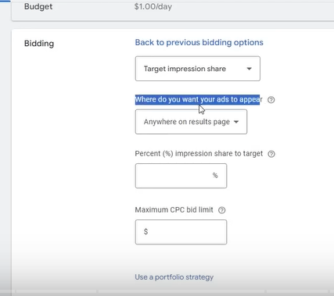

When we choose target impression share then we will see above textfields

First now we will understand what is Impression share

It means that

Suppose if average 100 people are searching for a keyword monthly

Then 100 people ar our maximum impression share

SO if 100 people are searching for a keyword ten maximum our impression share will be 100 people

NOe out of 100 when we target that atleast 90 people sees this ad then we kset target impression 90 percent or 95 percent if we want to show our ad to 95 people

Now in the second field we ask where you want your ads to appear   
then you see option as shown below

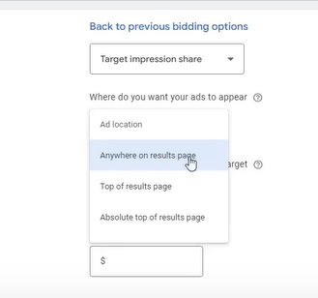

If you choose Anywhere on results page then you want that your ad should be shown to on top 4 or bottom 3

Now if we choose Top of results page then we means that show the ad to the top 4 of result

Now is we check the Absolute top of the Page then it means top 1

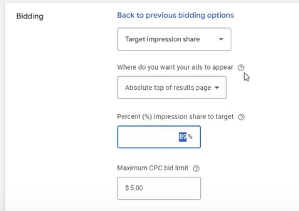

SO above configuration is saying We want top 1 position with impression share target 85 percent and maximum 5 dollar will be paid for one CPC

Now comes out Manual CPC

We set bid manually

For each keyword or ad group we set manual bid (who knows)

Means in this ad group we want to spend maximum 3 dollars per click or we want to spend 3 dollar on a keyword then we set that manually

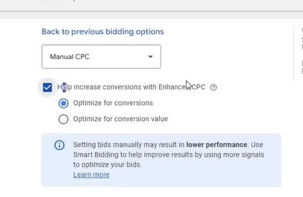

Now then there comes two options of the Optimization for conversions and optimisation for convergence value initially it is not recommended because new account don’t have any information or data to analyse in it and don’t have conversion history in it so it is of no use at that time

If it run after some time then you can use it but in starting it has of no more use

It is initially useless but after 20 or 25 days it has use when we have data in it (who knows)

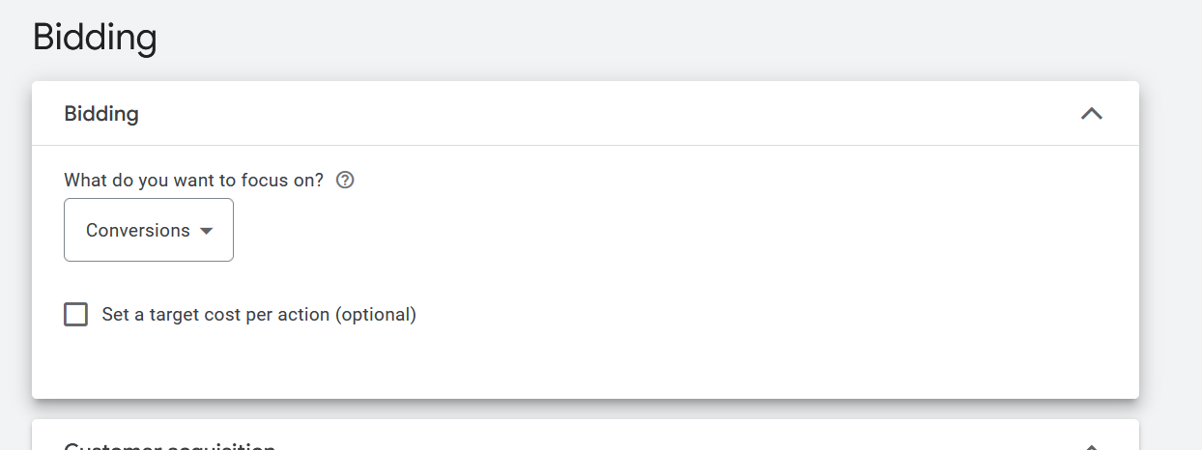

So we choose conversion

And now click on next button

**Note:-**

I think the campaign setting is for the configuration when you make a campaign

So whatever we are doing is actually Campaign settings

Now next option in our campaign settings is Network

You can check the set target option and then set the CPA

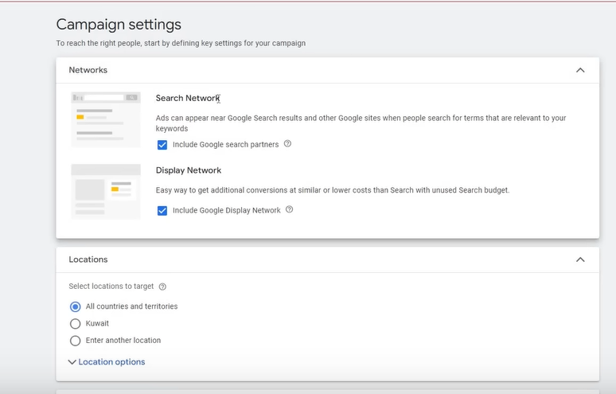

Now we have an option of networks

It means we will run on ad which are seach partners of Google , ask.com, amaon.com

In Display network we want to run our text based ads

If you are running a campaign then don’t mix thewe networks

Teachers usually does not usually use Display network

Because whenever it is used then you does not get convergence you cost get reduced

But you don’t get convergence your budge

Because it get spend on unnecessary places

Necasue in display network text based does not work good

We need to made visual based ads and many thing to do

We need to do different things

SO display netweork is not efeective according to the teacher

In Search network there are two things that we do

First is we test it and run it for 2-3 weeks and then see in data that how many convergence we get and how much convergence is from Google Partner

If it is profitable then we check its checkbox otherwise don’t check its either

In outside country it works

Many times it happens that convergence is happening in low cost and good convergene so it is a goog function

In India it does not have that mch bit it in other countrird hvar lots of use.

But of you want to test it then test it

Now we will understand the location

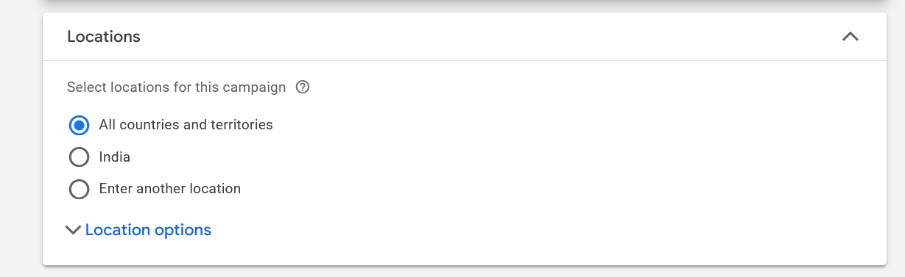

If we choose All countries and territories then we want to run in all countries and territories

Or you can run in which you are located at

And if you choose third option then you canchosse your country

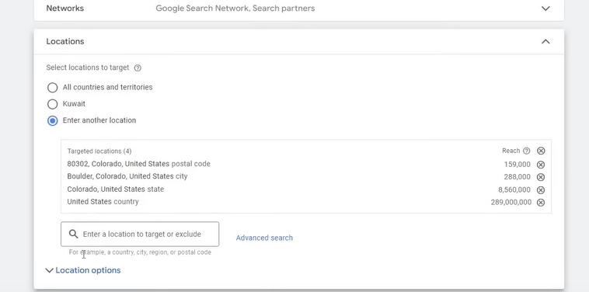

Now we can choose rregion by country, state , city , postal codes

You can exclude regions also

When you search some region and then hover over that option

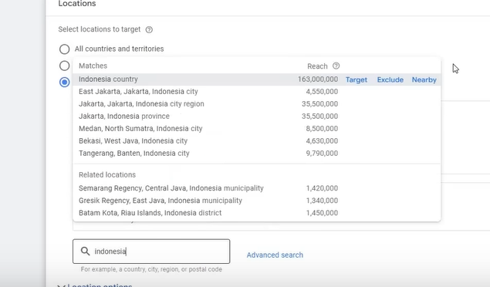then you see the option target to include and exclude to exclude and Nearby for all Nearby location in the region but it has no generally any special use

Exclude is used when your traffic is coming from an unknown country

**Lesson 4 :-**

In this we will see the part 2

Now if you want more option then you can click on marked below link

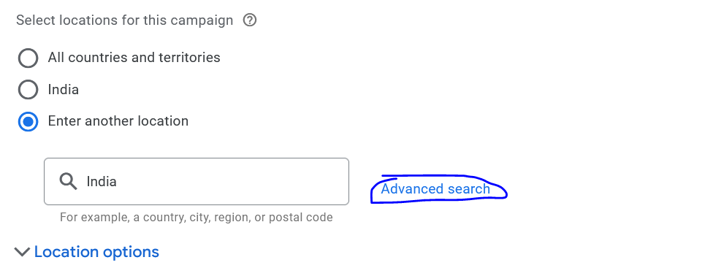

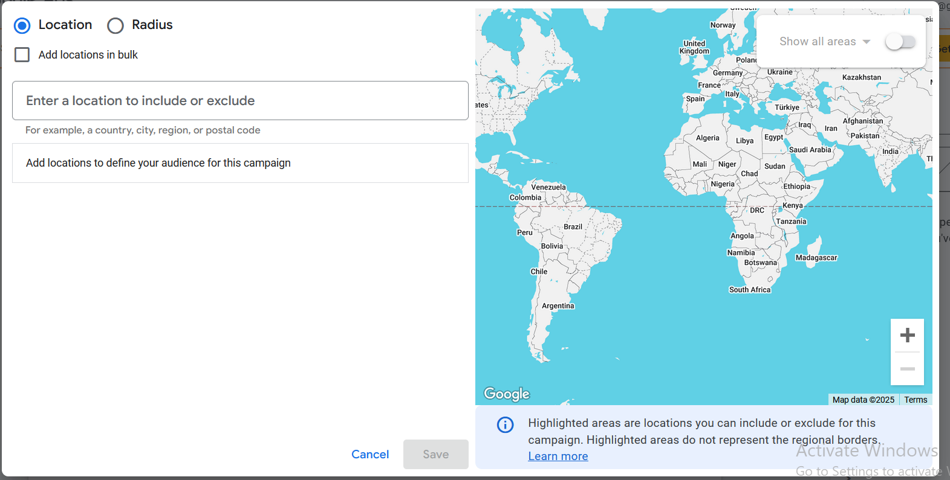

Now you can search above

If you check the Add location in bulk then you can add or exclude location in bulk

Now search the locations by typing in the textfield and desperate them by new line and then click on Search button and then below it all the location will be given to target in bulk or exclude all

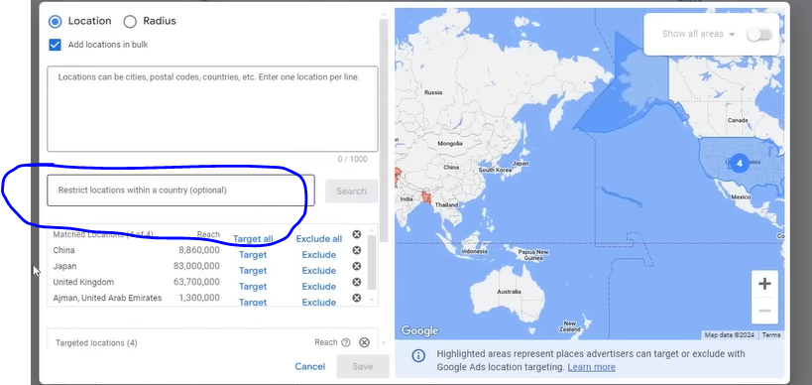

IN the above marked you can restrict a location within a country who knows

Now you can target the location according to the radius by opening the Radius tab

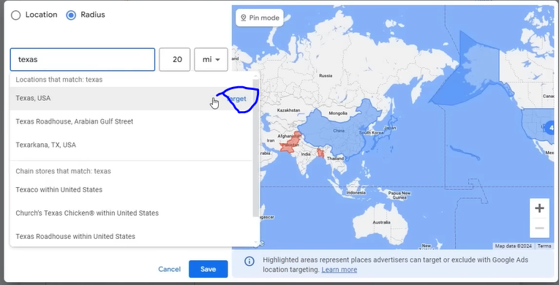

And then by clicking on the marked area you can include the texas region

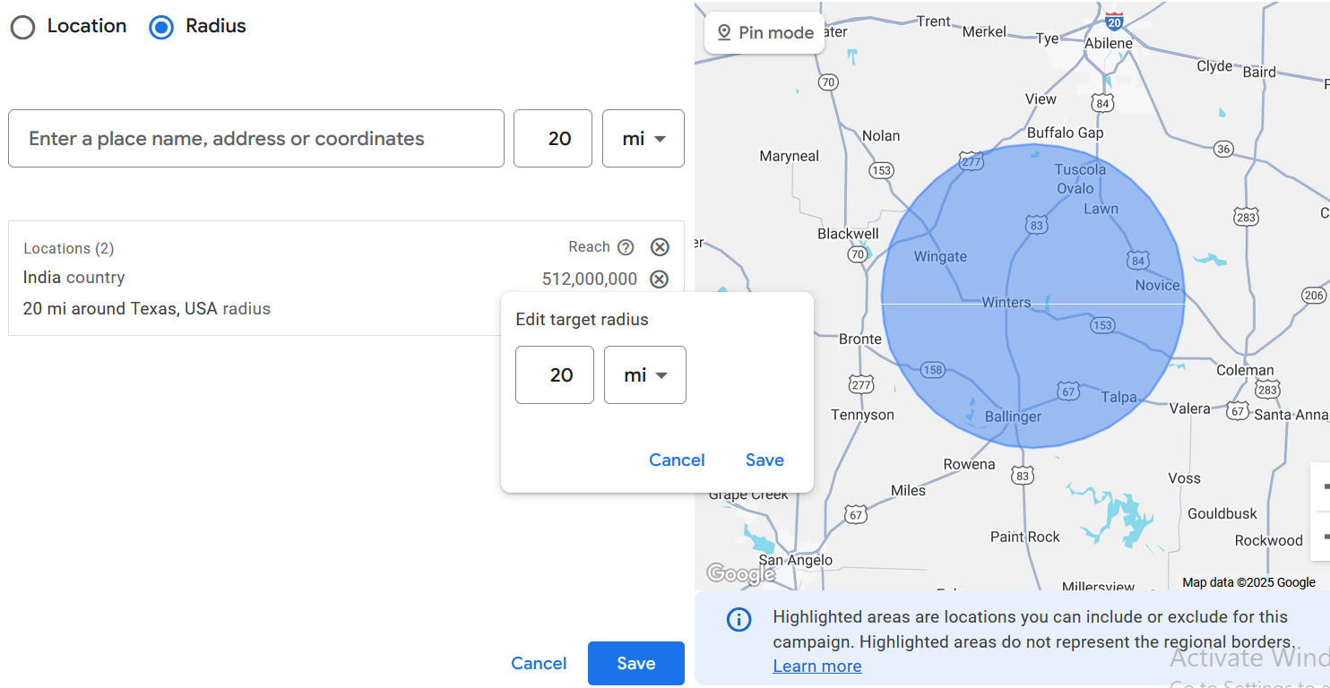

Now after including click on edit button when you hover over the added option and then you

**Phase 6**

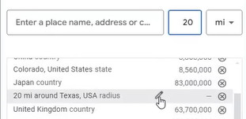

click on the edit button then you see the small box as shown above and now you can toggle the radius size

It is for those who do location based business there work is always nearby position like dentist or plumber

With the help of radius targeting their ads could run

Now click on Save button

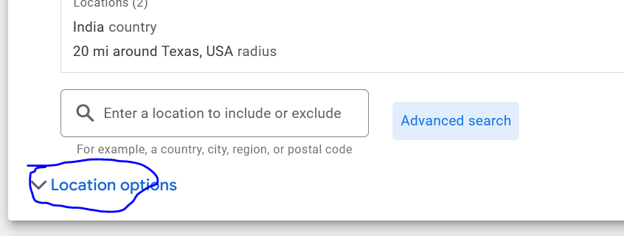

Now you will see the marked option as shown above

It is the hidden option given by the google so many don’t know about this

When you click on it then you see two option that is as shown below

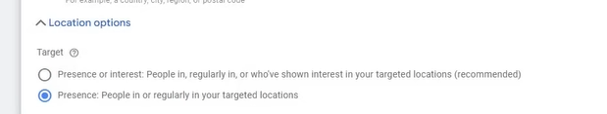

First we understand Second option that is Presence It means that the target location we selected whatever number of people is in there if they are present in those location then they will be shown ad otherwise not

If we choose first option then ad will be shown to people in that location or interested in that location

So if we search mobile shop Delhi then we are interested in it

First option is recommended because according to google where there are more ad spent that is recommended

But according to tutor second option is best

Because by first option it can happen that from outside the traffic will also come

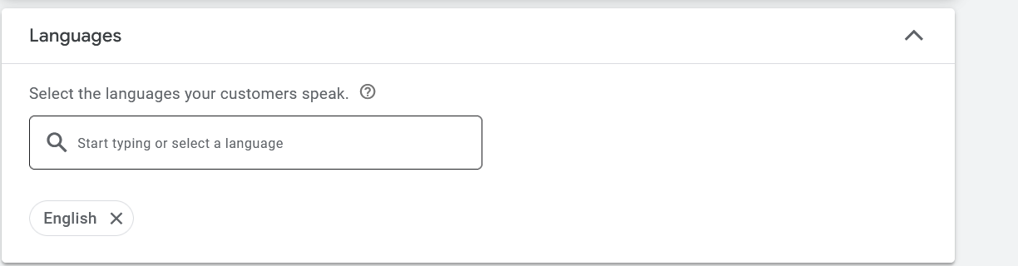

Now comes the language Language is an important thing

It is recommended to keep the language as same as your website first language

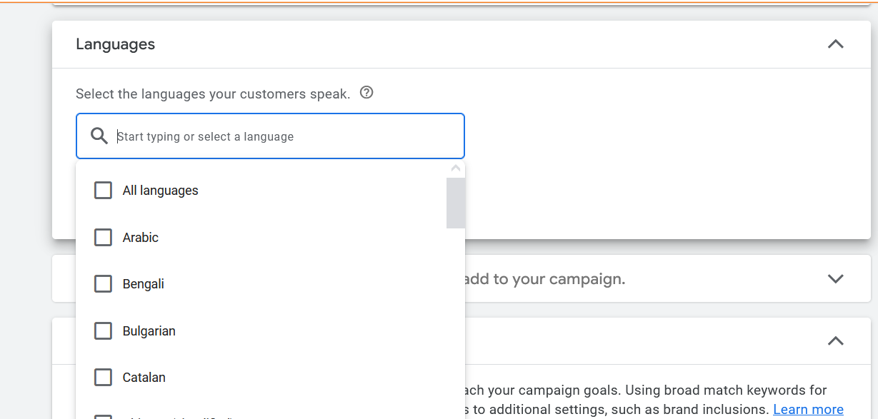

You can also add languages here by typing in the search box and then in submenu choose the language

It is because if your website is in a particular language then that people speaking that language will view that website

And now we come to audience segment

Now in audience section I think here we target people according to their characteristics or the interest they are interested in

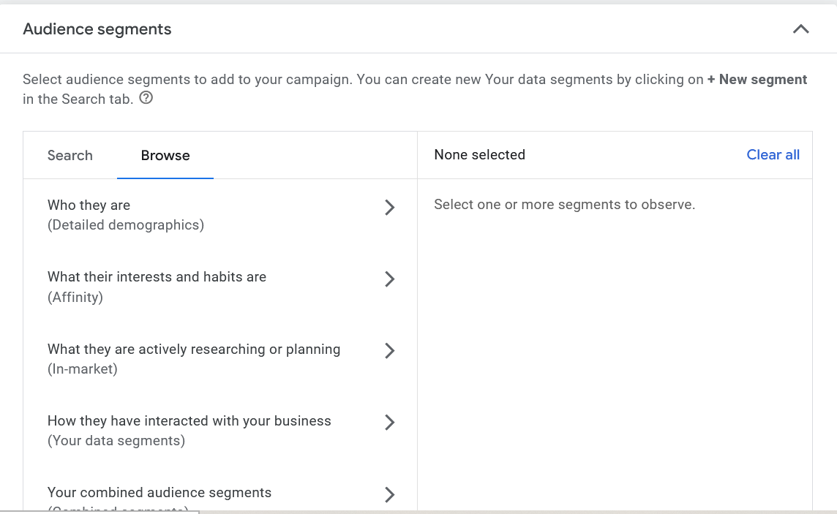

Now in Audience segment if you go to browse I think here you tell the characteristics like age , gender of the people you want to target

Her you get the option of detailed Demographic, Affinity, Inmarket , your data segment ,combined segment

By detailed demographic we know your demographics

age gender come in general demographics but when we talk about detailed demographics is his detailed information like Parental status , Marital Status , What is education ,HomeOwnership status , Employement like company size these all things come inside it

Click on it to expand it

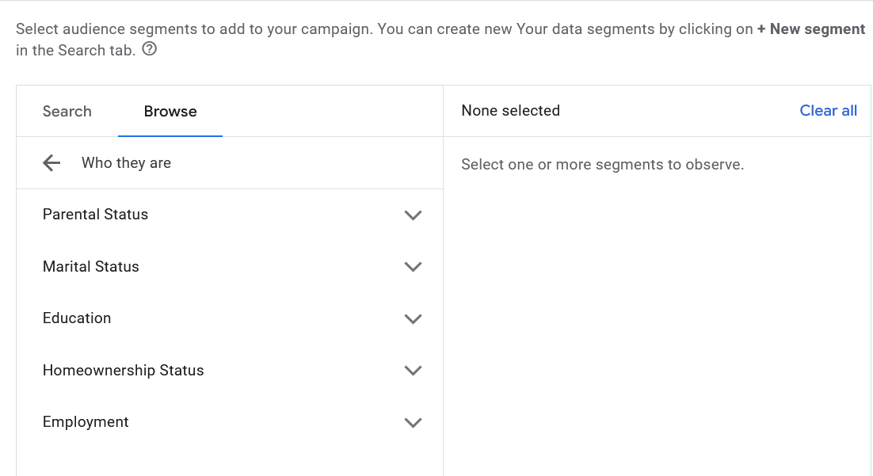

Then comes the Affinity audience

By Affinity we mean these are those audience who have general interest in a product and they are searching for that product or services understanding them and reviewing them but they have general interest in it

Third audience is in market audience

These are those people who are ready to purchase mean they want o buy it they are actively comparing there prices and these are those audience whom can be a good buyer

So it mean those audience who are ready to purchase and actively researching about the product

Then comes the your data segment

In your data segment we come across many lists ahich google make automatically of all visitors or all users which we will understand later but these are the list formed by google or some are made by you(I think these are the custom audience)

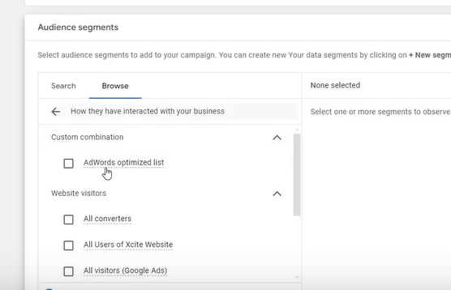

And then comes custom combination it is also made by the google or you can made it if you want

Then comes comes combined segment

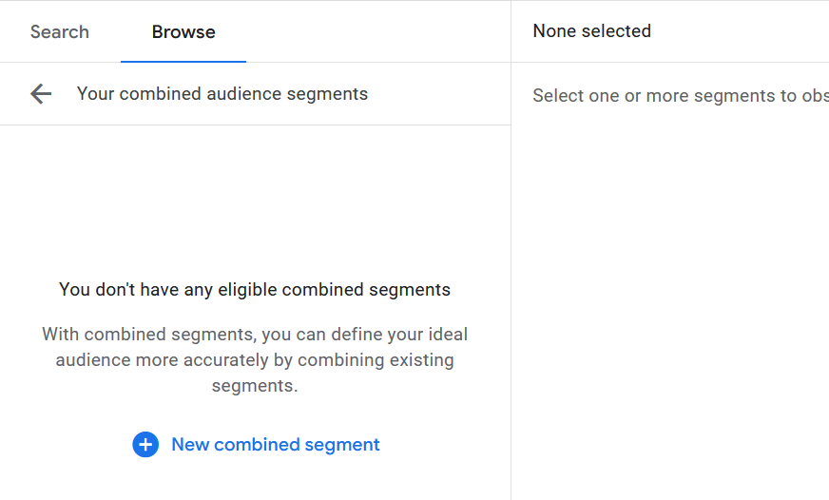

The combined segment does not have any separate use

But in this you can combine two or three things

SO to understand it we make one click on New combined segment as shown above

And then a new window will open

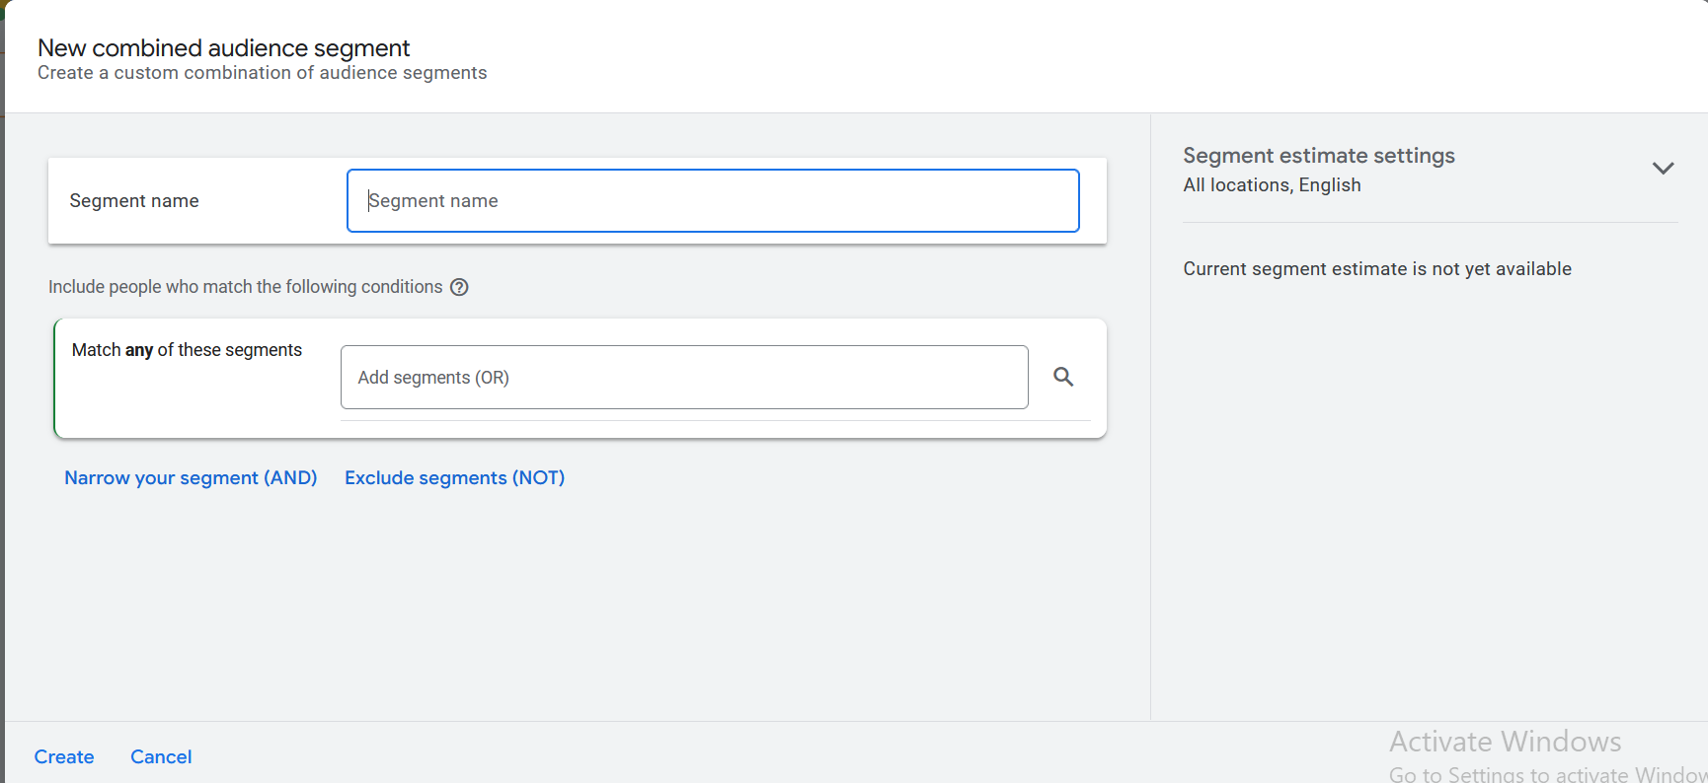

Here you can use and and not operator and then narrow or exclude the audience

So here we make a segment and if the audience have pattern of certain interest then they will come in the target

The combine segment add all other option to form a new option

Generally it does not have any special news and it is not used much

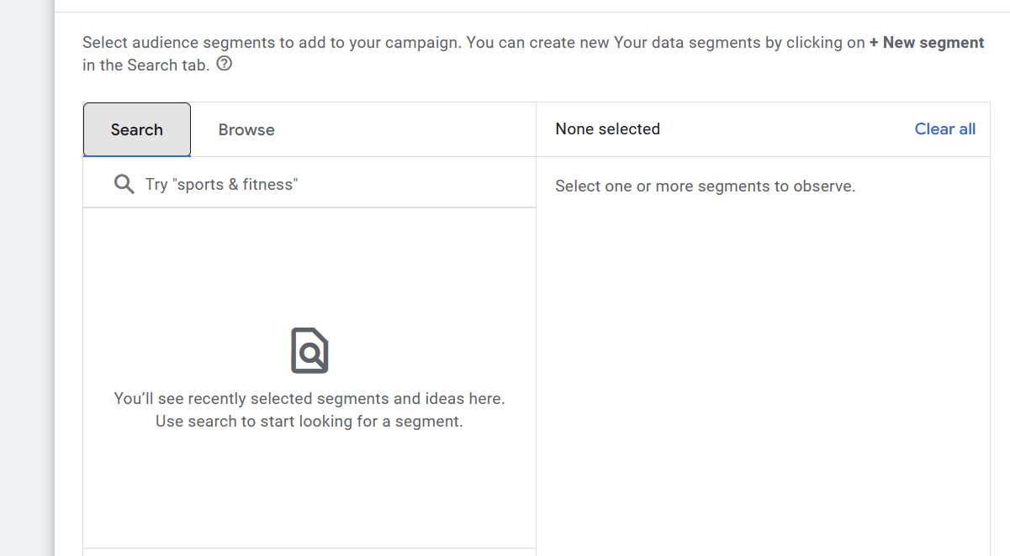

You can choose Search tab and here you can even search interest here

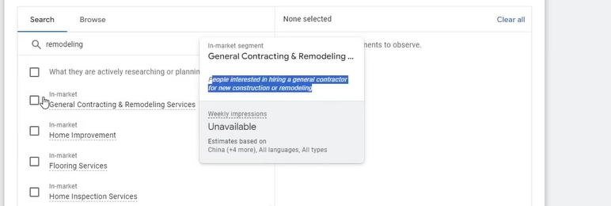

When you hover over the interest then it shows the box telling about it as shown below

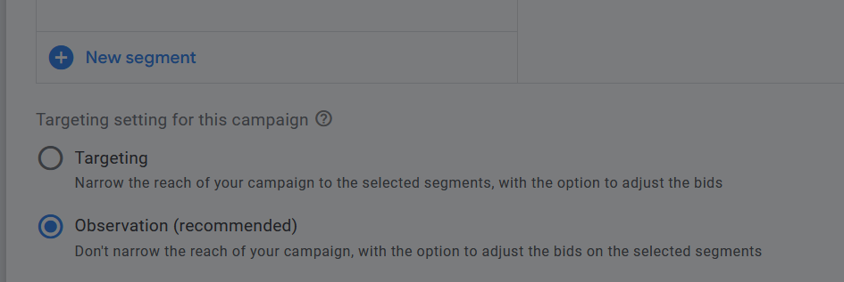

Now at the bottom of audience section we have Targeting and Observation(which is recommended)

If we choose targeting then

If the person is interested in whatever interest you chosen above then ads will be shown to them

Now if you choose observation

It measn the intereset or audience we have selected its data will be observed then see it which audience bring what conversion and performance there will be no targeting but just comparison that you will see when you filter your audience (who knows)

You will just do observation and see who is performing better and who is not and you can even target them in different campaign

In search campaing the targeted option will not be good because we are running keyword based because we are running already who is searching is not necessarily a good consumer(who knows) and other reason is that the audience get limited because if 500 people are searching something and only 30-40 people are searching related to your interested and then only show them SO not making it complicated so we choose just observation

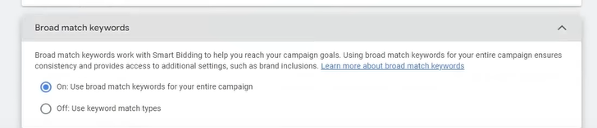

We will study above later

So keep it default

We will keep it off

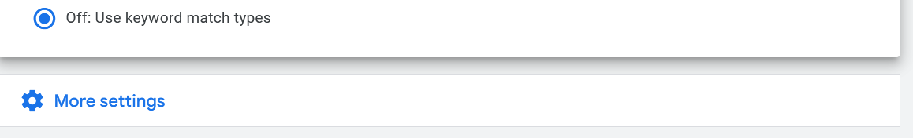

Now we click on More Settings it will get expanded and shown as below

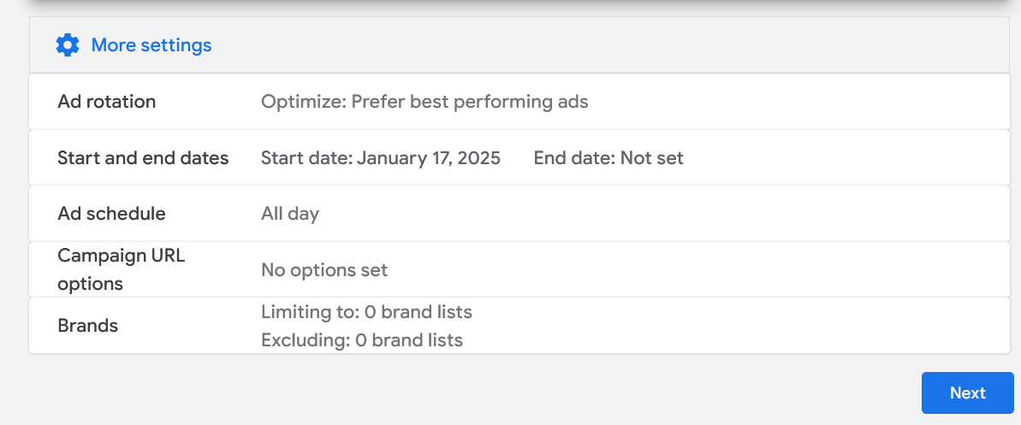

Now comes the ad rotation and now hover over the any option and then click on its edit button so we edit the ad rotation

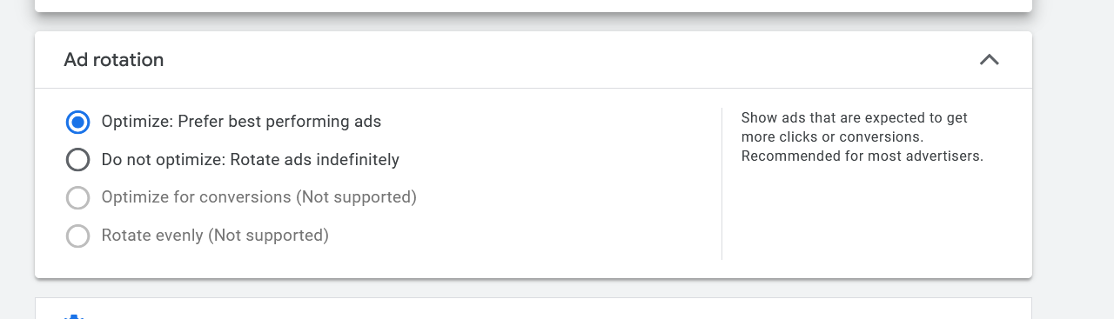

In above we have two option that is Optimize or non optimize

It means google will automatically optimize and then see which is ad performance and then run it

DO not optimize means

You all ad would be run fairly not one ad will run more thwn others

**Phase 7**

If you are doing your campaign monitoring them you can chose this option and the best option is first one that is optimize it

Now we will edit Start and End date

Normally how we work in Google ads we don’t change start date

When we want to stop our campaign we will stop it by pausing it

In End point then after that time campaign will not run after it

So if you choose none then you will manually start it and then manually end it

Here it don’t have any specific news

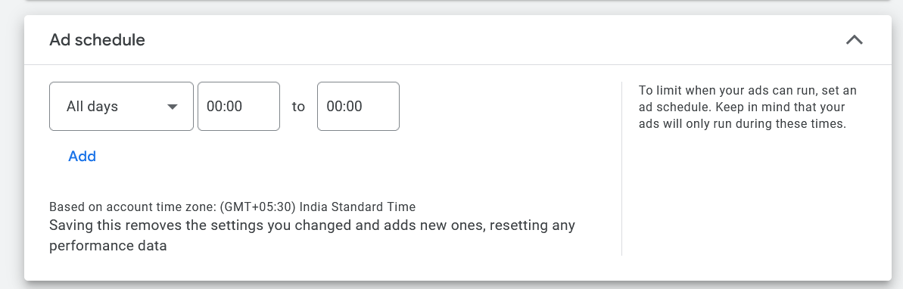

Now comes the Ad schedule

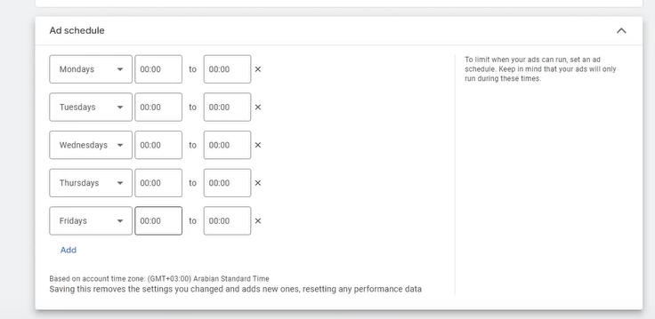

You set the days or the date and timing you want to run the ad

Herewe ignore the other option there are of no use

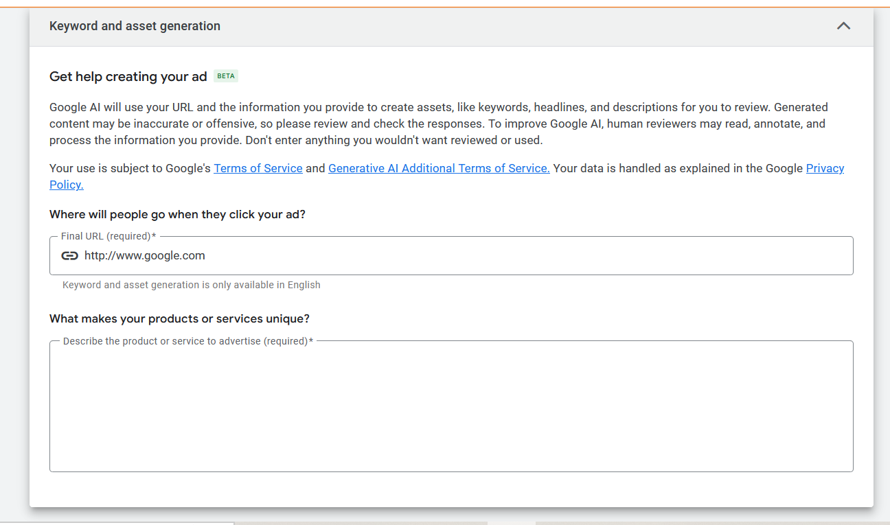Now comes above

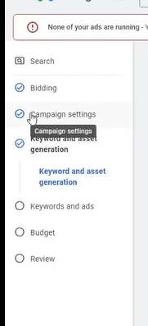

Now we have completed the Campaign Settings

SO we have learnt how to make campaing npw we will mpve on ot next step that is making an Ad group and then we will understand ad group and ad

Next topic is our keyword because like ad group is setting in campaign similarly for adgroup we have keyword or ad set

Ad group is itself a plave where the keyword and ads are saved

**Lesson 5:-**

In this lesson we will learn about **Keyword Selection for Google Ads**

In keyword topic first thing is Basic criteria for Keyword selection

First point is relevancy mean our keyword should be relevant

For example if you are selling a mobile phones for example we are targeting keyword mobile phone then here it does not make sense and its intent is not clear so if we go to a very specific keyword that is buy mobile phone , mobile phones cost , but android phones if we go to this type of keyword which are relevant and its intent are clear to us that he is searching for purchasing or searching for services SO a relevant keyword is very important which is the first point in the basic criteria that is relevant

The second option is Sufficient Search Volume

It mean the keyword you are targeting are enough number of people searching for it

For example if there is a keyword which is being searched by 10 people in month then what will be the benefit in targeting them

So keyword should be like who have considerable sufficient search Volume we will see it in detail how to recognize that keyword

Third point is affordable means the keyword you are targeting or you are using it should be affordable

For example if you make a keyword list

In that you get 3 dollar keyword there and you can see some keyword of 7 dollars then you chose 3 dollars instead 7 where your overall campaign cost is increased

After the overview Now we will se all of them in detail

For that we need to go to tool We will learn a tool here

Google Keyword planner you will get these tool inside google ads

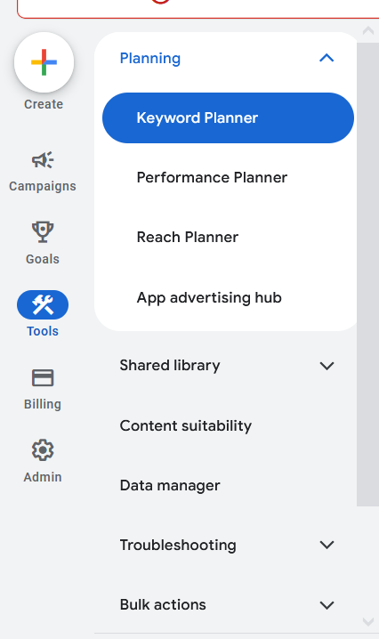

Now we will go to Tools side menu and then go to planner and then inside it go to Keyword planner

Here you can see other planner with keyword planner

It will be used ot find keywords

It is free tool you don’t have to pay it

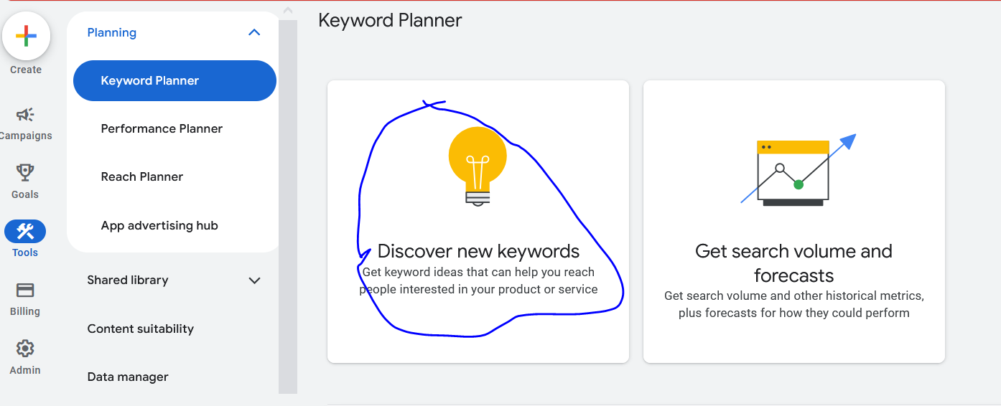

Now we click on Discover new Keyword option as marked above

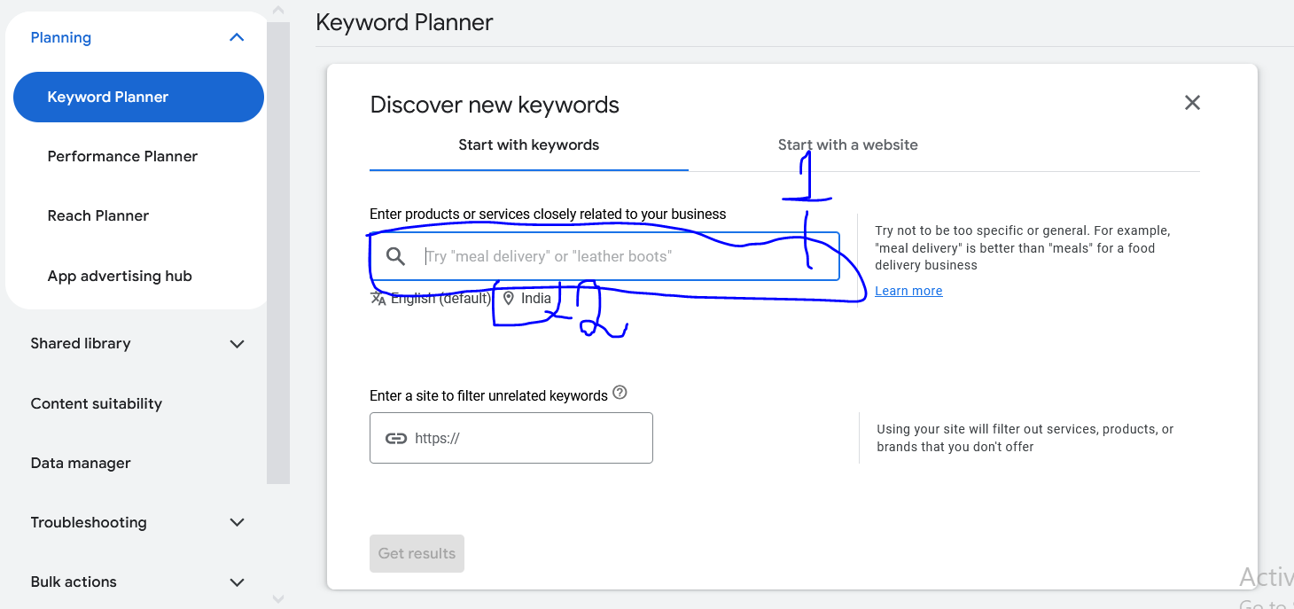

Now you can see Keyword planner as shown above

Now if we search something in marked one above here then it will give us keyword

For example if we

Click on marked 2 then we can choose the location we want to target

Now a new window will be opened as shown below

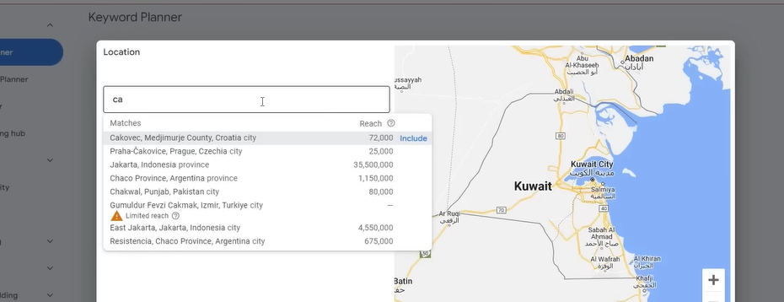

After doing it click on save button

Now you type the keyword you want to search

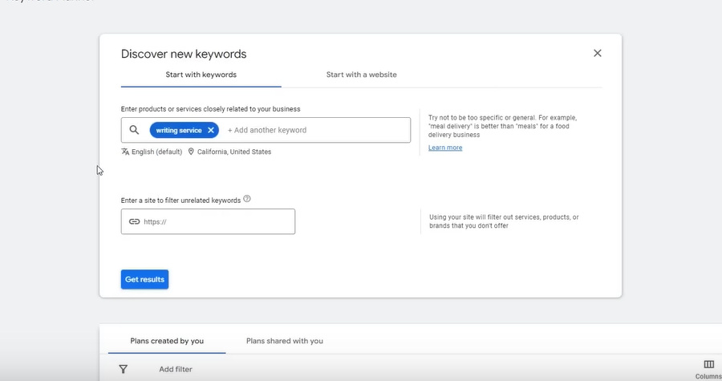

After choosing the location and type the search key word I think we are here searching for keyword relevant in that location and the language is English( same as our website)

As you can see above there are two tabs that is start with keyword or start with a website

The option of entering a site to filter unrelated keyword

Is optional

You can skip it is not that usefull

Now we click on get result

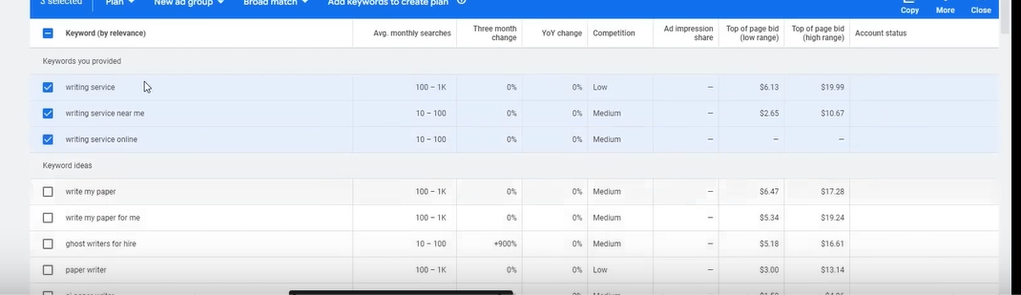

Now in the updated page you can see the keyword we search about and the keyword ideas related to the search

These are the keword google think is googd for you

First thing you need to do is that is this keyword relevant or not

And second you need to check is that you should have considerable search volume

As you can see the search volume is in ranges

The new account you make the search volume is always given in ranges

But when you spend some time in your account then it shows everything in exact number

And there is hidden data that is some graphs that also get unlocked when you do some ad spent

Teacher is showing some old ad account for demonstration where the data is shown in exact numbers

Now in old ad account we enter the same in input this time

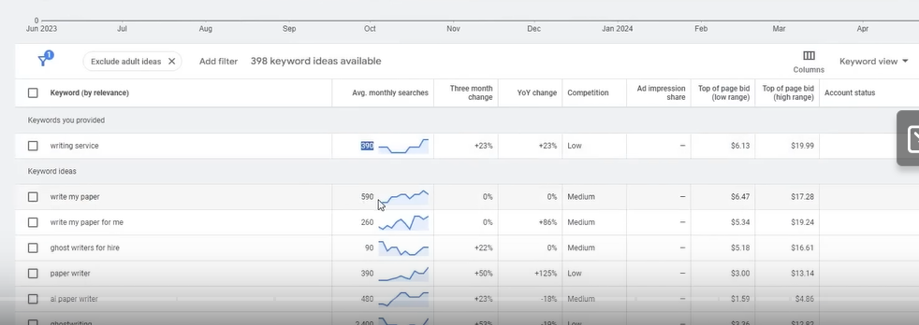

Now you can see exact number as shown above

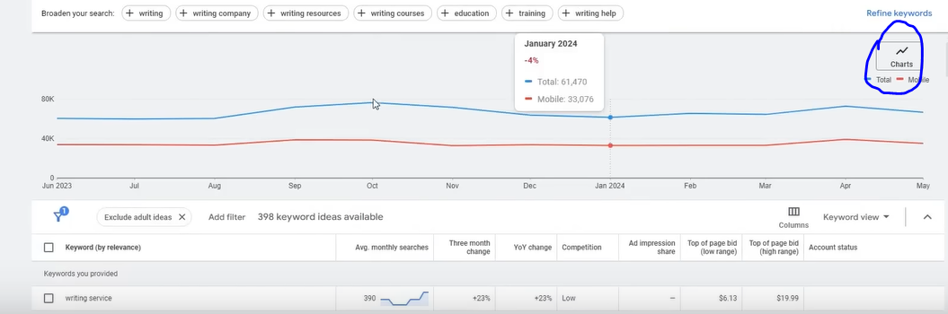

Now you can see also the graph as above ans also the options by clicking on the marked above

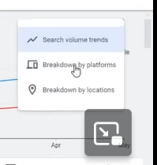

You can click on breakdown by platform by which we can see from what platform we are getting what traffic

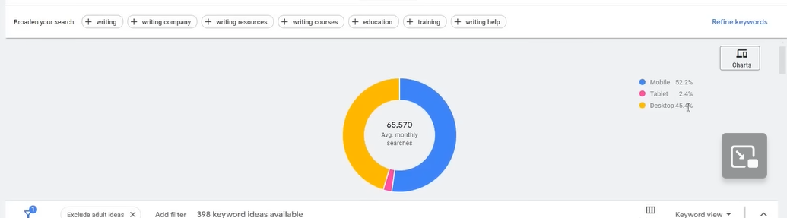

Now graph will look like above

Now we will click on breakdown by location then it will tell you according to the location

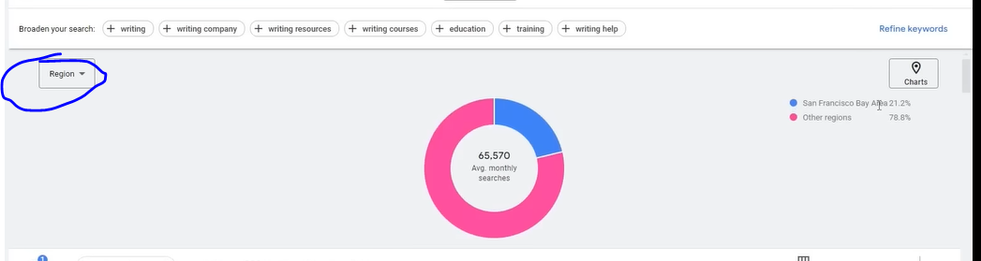

Now you can see the graph as shown above Now you can modify the graph according to city or country etc

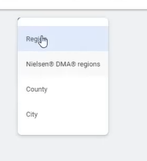

When you click on it there will be submenu as shown above

After you click on city option then below will be shown

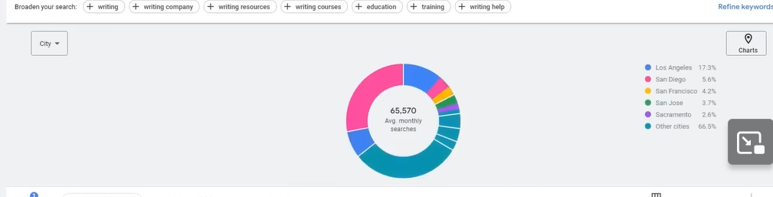

You can see in which city the ratio is better

**Phase 8**

And where it is less

You will not see the data in our new account

Only in your running ad account where there is your ad sense

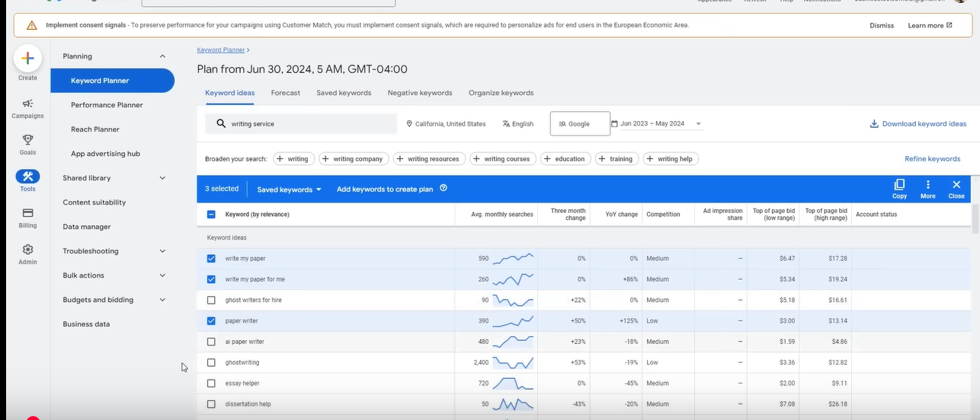

Now the keyword chosen are relevant and also have significant search volume

If you see a keyword with low search volume then it is not important to choose it

There are some niches where there is very less search volume where all the keyword search volume is less there they are selected

But if there is huge variation and some have huge search volume but some have very low search volume then you try to go for the more ones

Now when you click on the column heading then you can do toggle between sorting from lowest to highest and vice versa

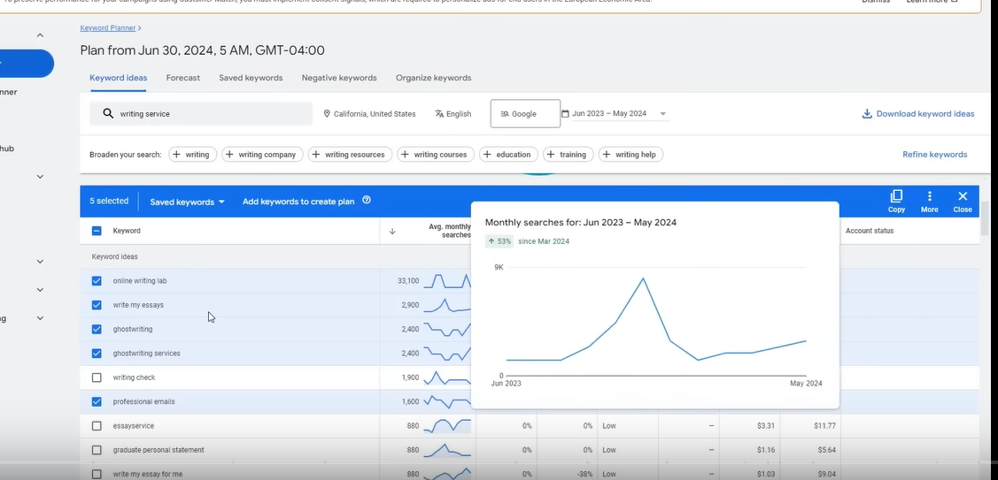

I think If you hover ot click on any small graphs then it will be expanded as shown above

Now these are the two the third one is affordability

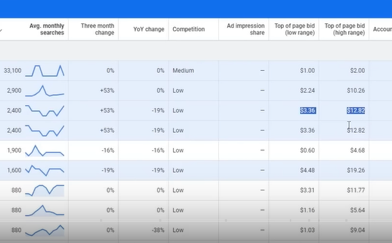

So there are some keyword which is 10 dollar or 12 dollar

And some can be expensive and if we choose expensive then our campaign cost will be high

Now we will understand the important things of this tool

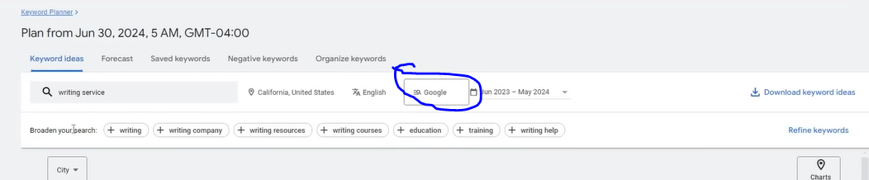

Now if you search something then below it you see some ideas called broaden your search as shown above

Now if you click on the marked above then you can toggle beween Seqrch on Google and Google and Search partners

We will choose Google because google have exact data

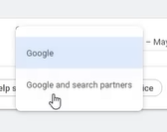

Now beside it there is option for Date and time to set duration of the data

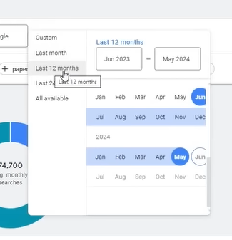

We will keep it close to 12 month and dn’t have to change it

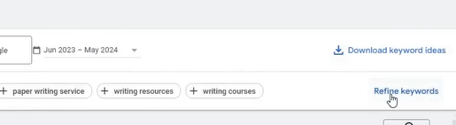

You can click on download keyword ideas to download keyword ideas

You can click on Refine Keyword to refine the keyword according to

Now you will the menus in sideways

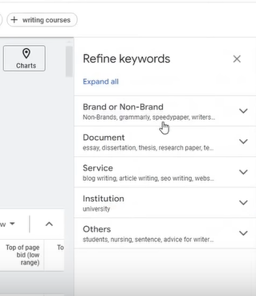

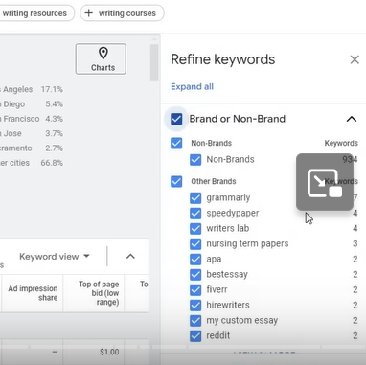

It will give us above categories to refine the keyword ideas

You can even categories on the basis of above categories

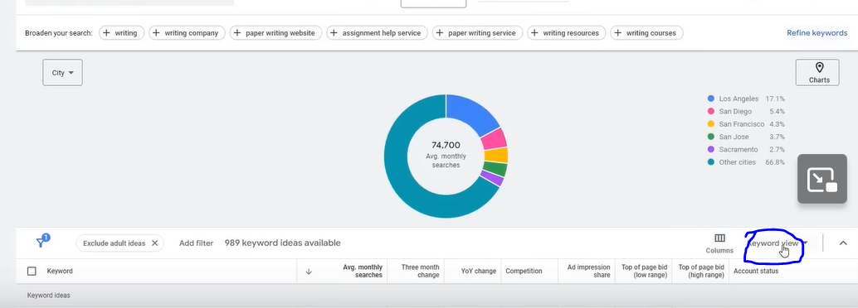

There is option as marked above to see your keyword result list in keyword view which we are currenty viewing or in Grouped View

In this view the categories are formed as shown below

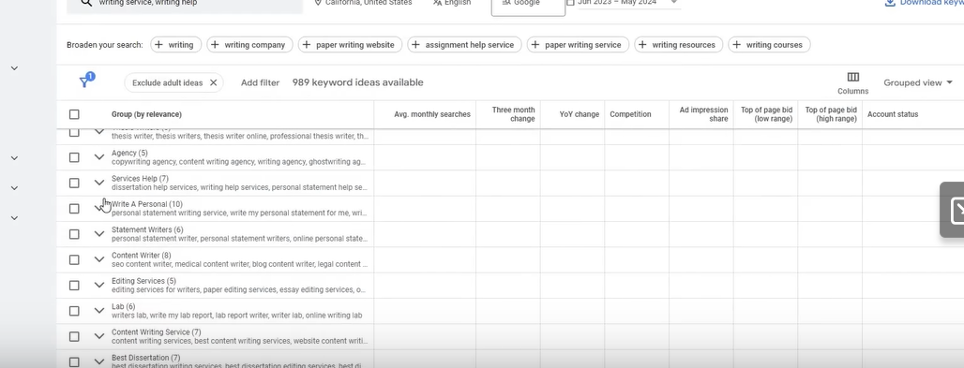

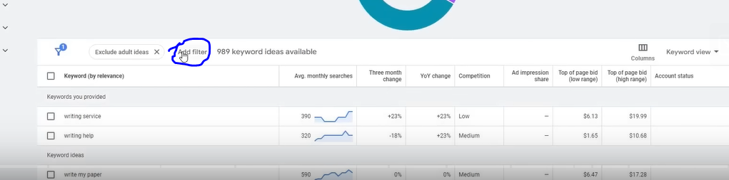

Now you can click on Add filter as marked above to filter the keyword list

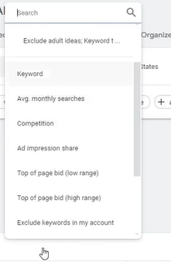

And then in the submenu click on the keyword option in the submenu

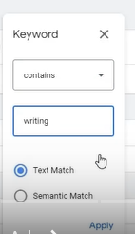

This will be helpful if your search result Is very big

You can filter it according to a word inside that keyword

You can also apply do not contain logic in filter

If you choose semantic match then it does not filter according to exact match but also according the meaning they convey

You can choose multiple words according to which you want to filer

For example if we choose in first field first option then in second field we write writing

Then we are searching a keyword according to a word inside it

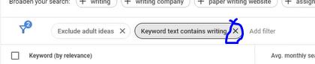

Now if you want to remove a filter click on cross as marked above to remove that filter

You can also filter according to average monthly search

You can filter your list according to what is the scenario or what is the case

When you add a filter you can see in the below where Add afilter is list

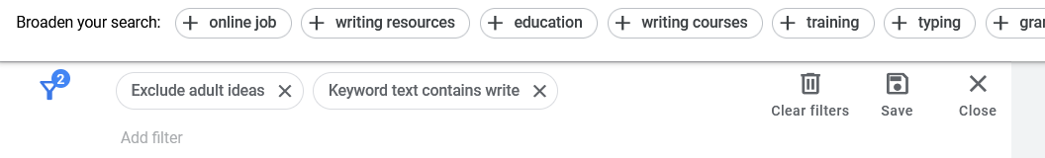

To remove it click on Close button

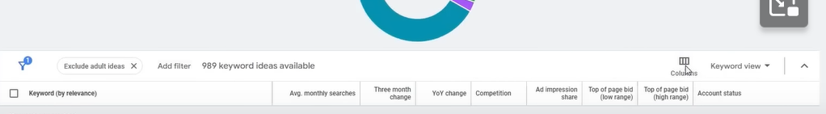

Now we will click on coumn oprion

Then there will be updated section as show above

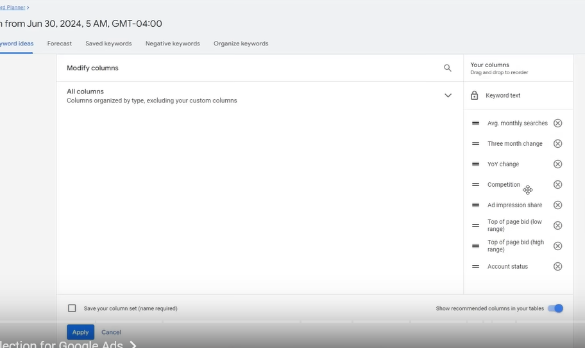

You don’t need to change that click on close button

This keyword planner will be used if you want to run ads on keywords

You need to search keyword here

You need to target that keyword and select it

We need to do grouping here(I don’t kmow)

SO first we need to understand that how to find keywords

How to find right keywords and what is their criteria which we understood now

There is another way that is another tab in keyword planner that is Start with a website

Teacher uses both of these ways he find some keyword in previous tab we studied and the tab we are studying nowIn this way whatever service you are running search about it

Like writing service California anx

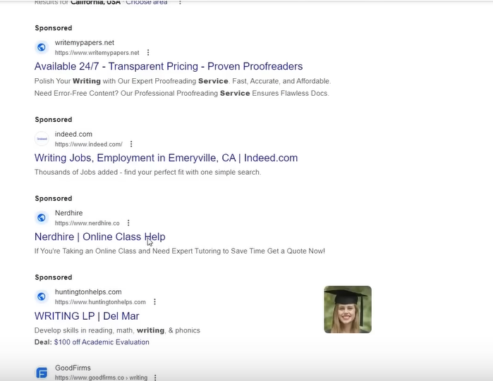Now you will see the result above

We choose firt website as shown above

Whatever website we have opened now copy its url and then

Paste it in the filed as shown below

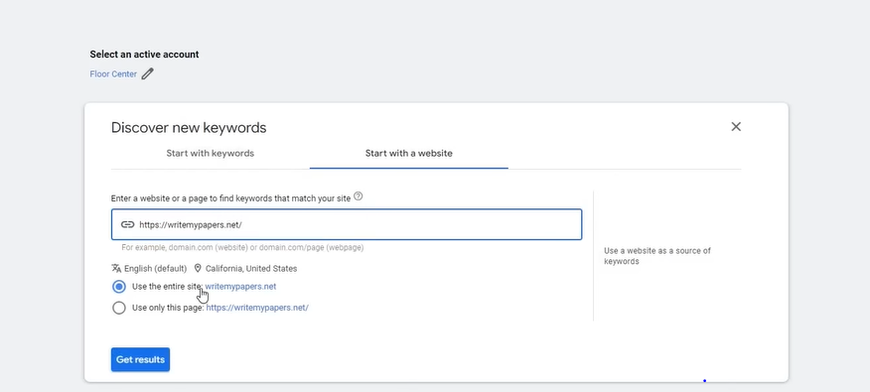

If you want to just use this page then choose the second radio button

Or for entire site choose first

If we have opened any product category then we would have checked second radio button

But in my scenario we want tot target the entire site so check the first radio button now click on get results button

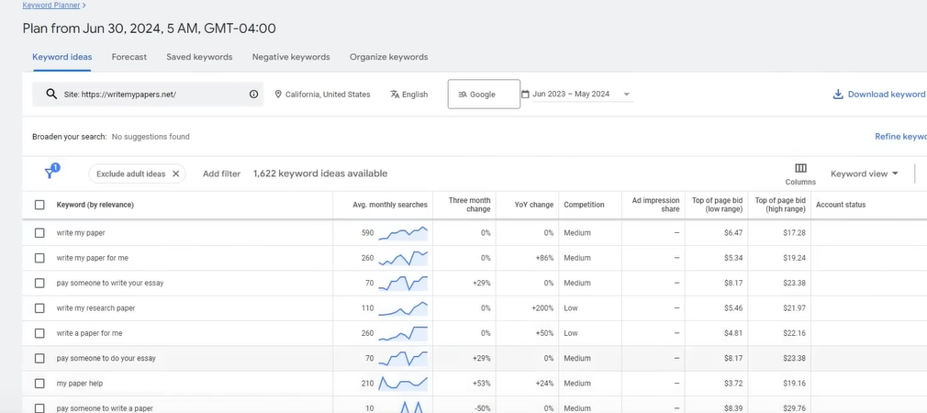

Now you will see somme keywords above

Here we get relevant and exact keyword

It is one way through which you can find your keyword or whatever your service is

I think it analyze a website and see what it does and according to itd research it suggest us some keyword

So use both way to find keyword.

Choose keyword which is affordable and other things whoch we discussed above

Now comes the common keyword category

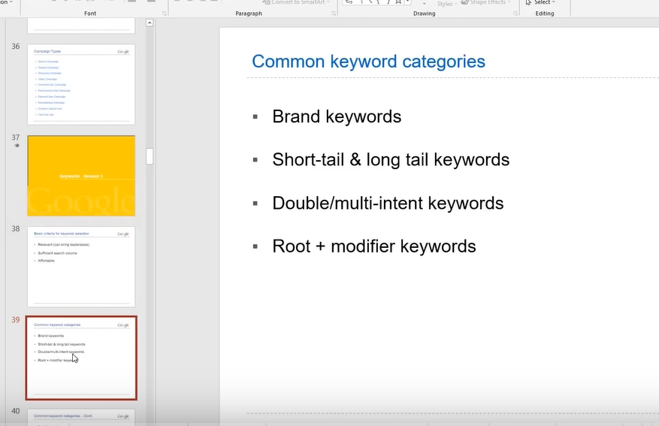

Now we will understand common keyword category

It is for your knowledge it will help you to understand your keyword but it has no direct relation with Google ads but there is indirect relation to it

First we will see **brand Keywords**

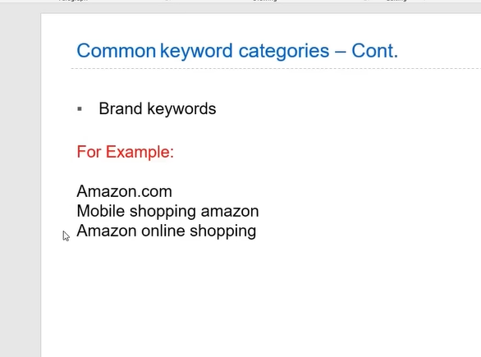

Its example is above

In brand keywords we have Amazon.com , Mobile shopping amazon

Measn if we are searching any brand then it is called brand keyword

Second is **Short and Long Tail Keyword**

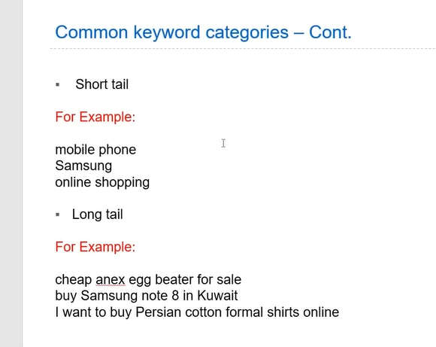

Example is above

Short tail are the keyword which is mostly of 2 word length

And the long tail is one which is of greater then 2 word length

Then we have **Double/multi-intent keyword**

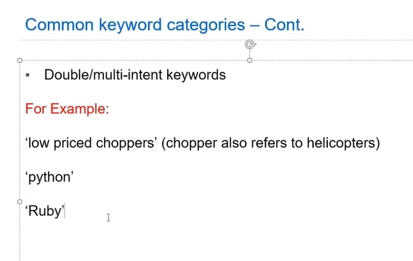

**Phase 9**

The example is above

I think these keyword is the keyword which have multiple meanings

Suppose the keyword python which is snake but also a programming language

And Ruby is a Programming language and also a gem

The comes **Root+ modifier keyword**

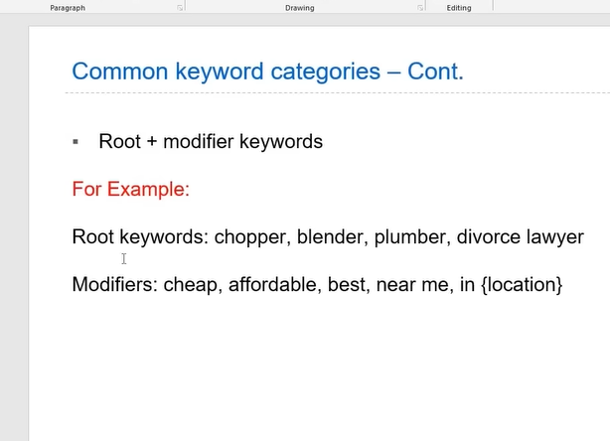

The example is above

Root could be chopper, plumber , divorce lawyer or any noun o think so

And modifiers in include cheap, affordable, best , near me , in {location} I think specify the meaning of the keyword in detail and more clearly

You can also mix them like

Cheap plumber near me

It comes in handy in your ad headlines when you insert keyword inside it that how you can carefully represent it.

Now we need to differentiate between Keyword vs Search Term

Keyword is what we give to google and put it in google ads

Search term is what people search in google

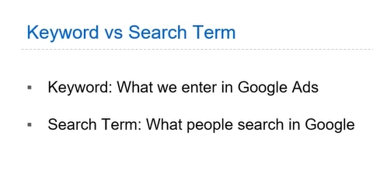

How they get differentiated and why different occurred between them we will understand but before it we need to understand that Keyword is what we enter in google ads

And Search term is what people search in google

Now you think what is the difference between them

Its main reason that they are differentiated is Keyword match types

It is responsible that your ad will be shown in what keyword

For example you put mobile shopping California this is the keyword you put in your goggle ads then it does not mean that your mobile shopping keyword will not be shown on other than California

It means it depend on the match type that this word will be shown in what variation

Because if you run your ad on the keyword monile service California your many potential will get lost lkike best mobile shopping in California and mobile shoppin califoria near me and they are your important crucial keyword

That would not be missed google introduced some concept that is keyword match types

They are the one responsible how your keyword will be shown in google

First we will study in detail later

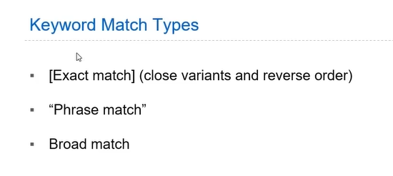

But for now there are three match types that is Exact Match , Phrase, Broad match etc

The exact match are surrounded with square brackets

Phrase match are enclosed in double quotes

And we keep broad match simple

Now we see in detail

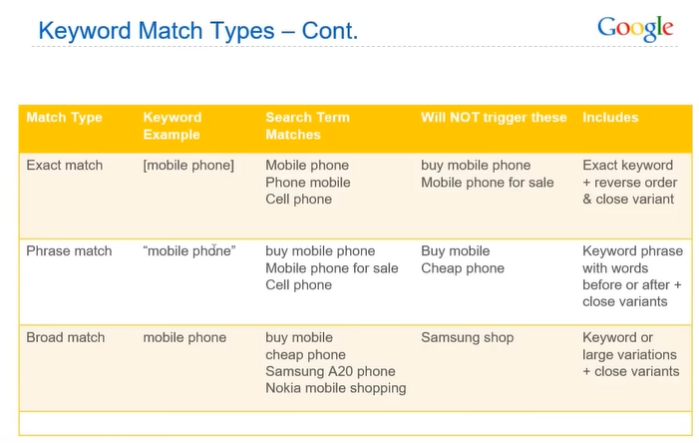

With the help of table we will easily understand that why they are different what difference it creates

Now we see exact match and you see third column that is search term matches

Here you will see what type of search matches can be matched

In fifth column its definition is shown that it matches in exact keyword or reverse order or close variant

In fourth column the search term will be shown that will not be matched

Lets say we take an exact match mobile phones

Then the match term for exact match will be mobile phone itself and the reverse order will be

Phone mobiles and for the close variant we have

It will not trigger for buy mobile phones or Mobile phones for sale

It means occurance of mobile phones is important

No keyword can come before it or after it or iin middle of them

Yes close variant can be possible (maybe same lengh is required who knows)

NOw we will see phrase match definition in fifth column

So in this if any word come after a keyword or before the keyword then ad will be shown or if there is close variant then the ad will be shown

Now we will see definition of Broad match which is Keyword or large variation + close variant

For keyword mobile phone in this type there is no barriers

If there is a mobile in search term then still ad will be shown or if phone is in search term then still ad will be shown if there is no word occurred then that will not be shown like Samsung shop

I think the variation is anything that include a word of the keyword

In broad match if your keyword get separated into two parts mean in some search term mobile occurred or another phone occurred and will not be shown if any one of them will not be occurred

It is important to understand it because it has a greater role in future

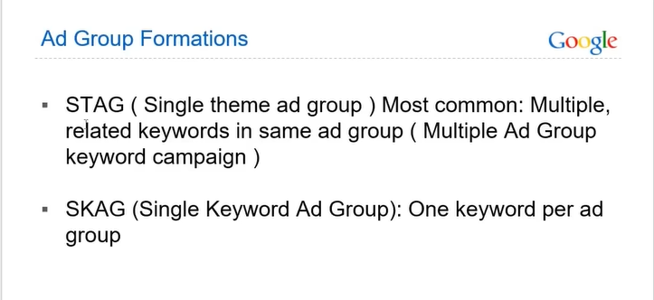

Now we will see Ad group formation

In this we have two types that is STAG and SKAG. Whwn we make ad group and we put it keyword or ads in adgroup

As we have told you there can be multiple ad group

To understand multiple ad group how to form ad group how to structure them

According to it there are two structures one is STAG and another SKAG

STAG in simple words means in this only one theme is taken here for example if there is mobile shopping Mobile shopping will be one ad group and all other keywords will belong to mobile to Mobile shopping ad group and ads will be of mobile shopping

And there could be another ad group for Tablet named Tablet shopping then the keyword ad will be related to it

But in the case of SKAG keyword there is one keyword for one ad group

For ecampke buymobilephone is an ad group with one keyword and ad is also related to it

But SKAG is now not used anymore now normally we use STAG formation in which servicew has one ad group and service 2 has one ad group

It will not happen that you will put all the keyword randomly in an ad group and you think it will run no

Formation is important whatever service you are running its keyword should be correct and ad should be relevant that;s why ad group formation is important

We have already discussed Keyword planner

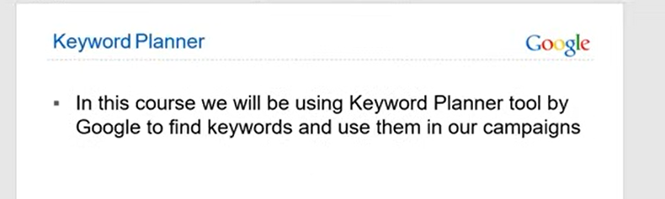

Now we go back to the campaign we were making

By going to campaign sidemenu in the googe ads dashboard

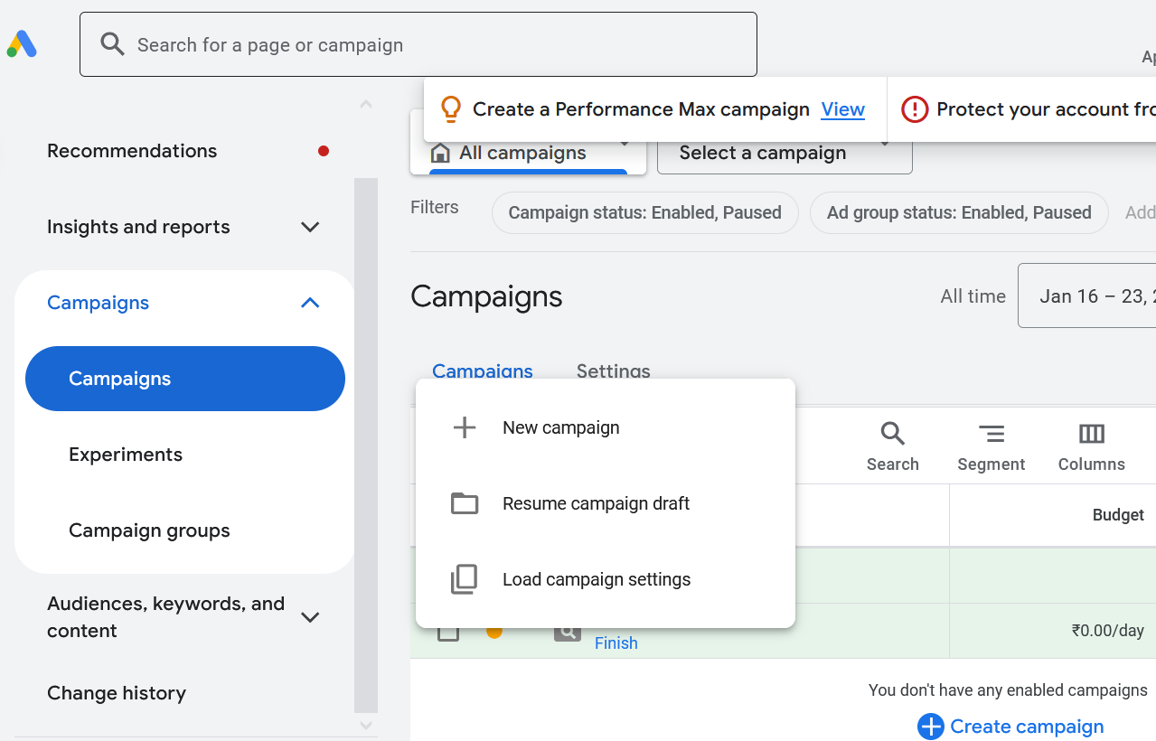

Now we will continue from where we did left

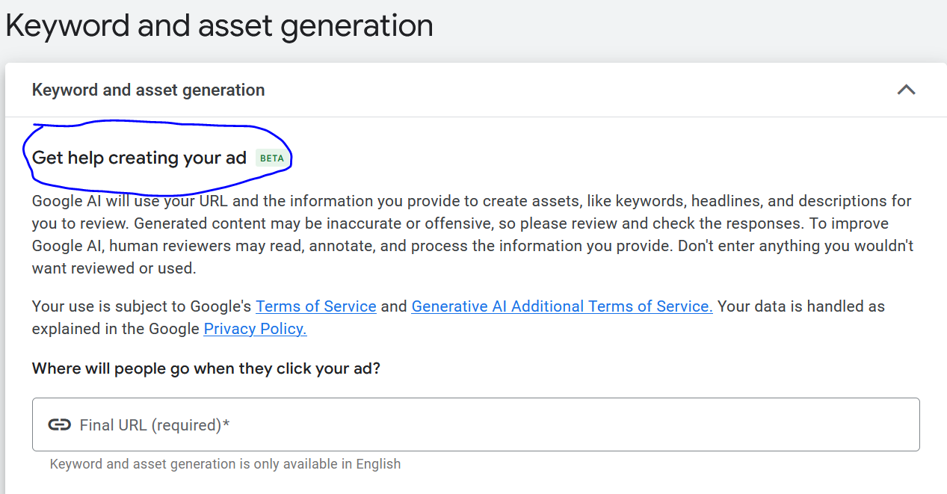

Now in the marked abive you can see there is new functionality whoich is in beta for now

IN the field above enter the url and see ads are generated or not

It is also good way but the teacher will also an alternative which will

**Phase 10**

Be good fir your ad and he will teach you hjow to write your ad

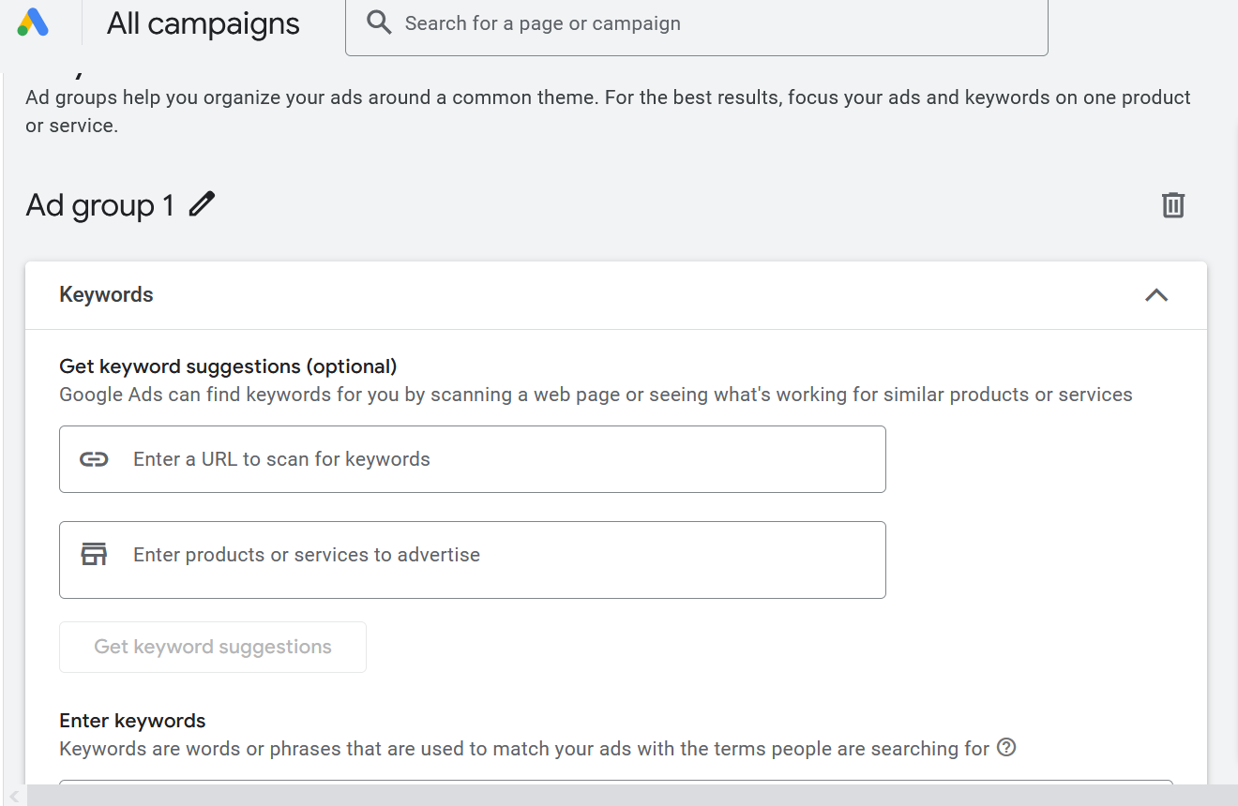

Now comes the ad group as shown above

Now name the ad group by clicking its edit button

Now go to Keyword planner to get dsome relevant keyword for you

The above keyword suggestion functionaliuty you see as marked above is similar to keyword planner but it is for Beginners so give limited results here

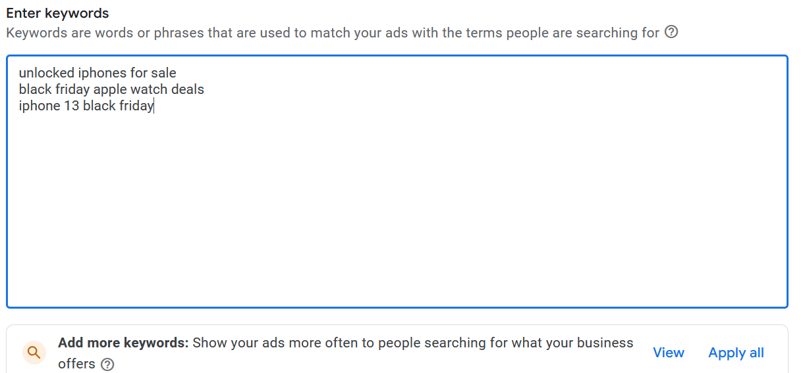

Now we will enter all our keyword as shown above

You can modify the keyword by the square bracket or “”

Teacher will tell us iun detail about it

You need to pick at leat 10 to 15 keywrod that will be availbale in your ad group

IN starting you could se thid but later you can even use more than

But the best recommende will ne 10 or 15

Now we named the ad group and make keyword now our next

Topics will come that is ads

**Lesson 6:-**

In this lesson we will learn about **How to create Google ads copies**

Now first topic in **anatomy of an RSA**

RSA meaning Responsive Search Ad

In google ads there is only one type of ad (who knows) that is RSA

But previously there were two typw

First was ETA(extended Tax ads ) and RSA

But Now ETA is not used anymore

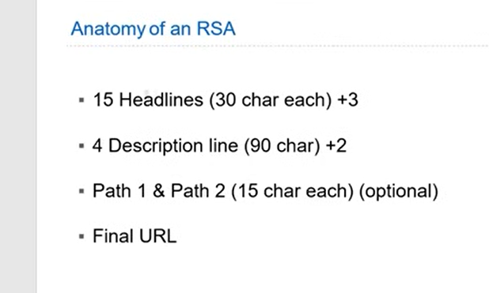

Format of RSA is shown above

Now in RSA you need 15 headlines(explained later) 30 character each as shown above

Now in RSA you need 4 description(explained later) 90 character each as shown above

Path1 and Path 2 (explained later) should have 15 character each

Now in final URL you have url which we go on when the ads is clicked

This is the anatomy of RSA measn structure of RSA

How it looks and what we need to keep inside it

Now we will show you practically how it look

Which we will see as scrolled down and see below

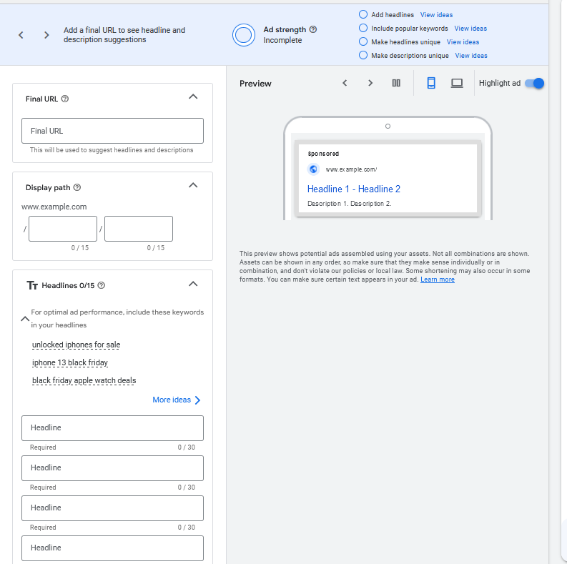

Now above you can see final url field

And then display path

This is the fake path that you will show whatever your url is

It is shown such that customer can get interest that he is getting specific or relevant information

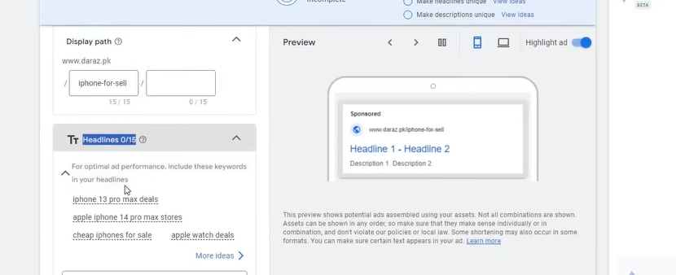

Now we have 15 headlines as shown above

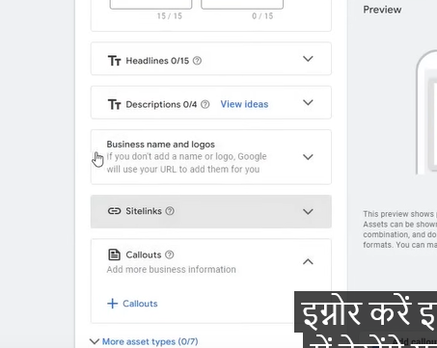

We have 4 description as well The bottpom 3 will be explained later this will be our next topic By filling the headlines , url, Descrition we get our RSA ad

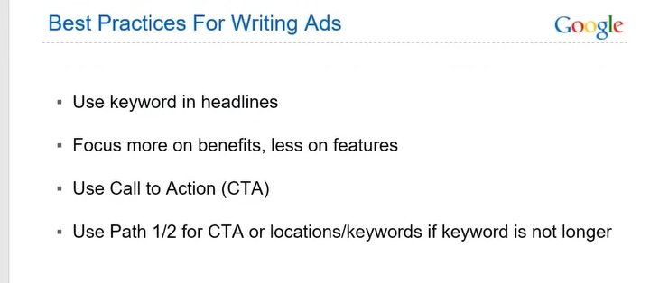

Now we will understand best practices for writing ads

First option is use keyword in Headlines

For example if you are selling in Iphone then you will not write android or Mobile phones so you need to try that whatever service you are selling there should be keyword related to it for example we can use buy I phone at best practices or top rated I phone seller or Top company for Iphone seller you can create your own variation which you think is good but the occurance of the keyword is important that you are selling

Now the second point is that you should try that yo should telk the benefit more than the feature

Normally when you buy phone then you see there feature but company does not advertise it that way Company just show you a lifestyle

Now how your lifestyle will be changed

Normally they show you high quality photo of the phone , your phone will look good with you so they sell you an experience instead of phone It is a marketing strategy you try to tell the benefits of the product Like we have 27 employees , in this service you will get these things this becomes boring you don’t need to do it like focus more on benefits like there is 24/7 customer support , High quality return , High quality service , best rated in the town , top rated company Top rated on Google that how you need ot tell we are just giving you an example but not an exact if you try to relate with it then you will understand

Third point is that Use Call to Action( CTA )

It is the button you see in your ad like But Now . Know More

They tell ou what action to take

Then comed fourth point that is Path 1 and path 2 for CTA or location keyword if keyword is not longer

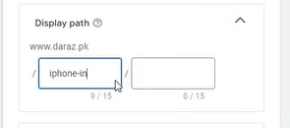

We have seen in Display path where we have used our keyword in the text

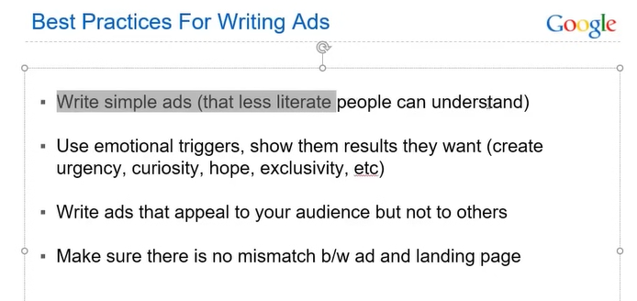

Now 5th point is tha Write simple ads understandable for illetrate people

Ad should not like that you havbe to open dictionary to understand it then you will not get the benefit so it is better you use language that the user can understand

Now coms the 6th point as shown above image which we will ee later with an example so we will skip it for now

Now comes the 7th point is Write ads that appeal to your audience but not to others

For example someone is searching laptop and you are seeling phone then you would not want that laptop person should click on your ad because it had no benefit

So you tryb that your heading or description should have a mention of laptop If you don’t mention it that you don’t sell laptops then he will not click on it

If you create ads according to the audience

For example buy mobile phones at best prices , best rates in town

If you write such thing in heading then he will understand that this ad is of mobile phone not of laptop some people literally write online shopping

Now how he will understand it when he click on it then he will assume that he is buying laptop

So that you need to avoid this mistake

Now comes the 9th point that is Make sure there is no mismatch between ad and landing page

Whatever you are writing in ad it should be communicated in landing page Now you are offering 30 percent discount in ad

**Phase 11**

But there is no mention of it in the landing page

If you say in the ad that we have best customer support and there was no mention in the landing page

So avoid these mistakes

SO make sure whatever you are saying in the ad should be shown in the landing page

We do’t write ads manually now because there are AI tools

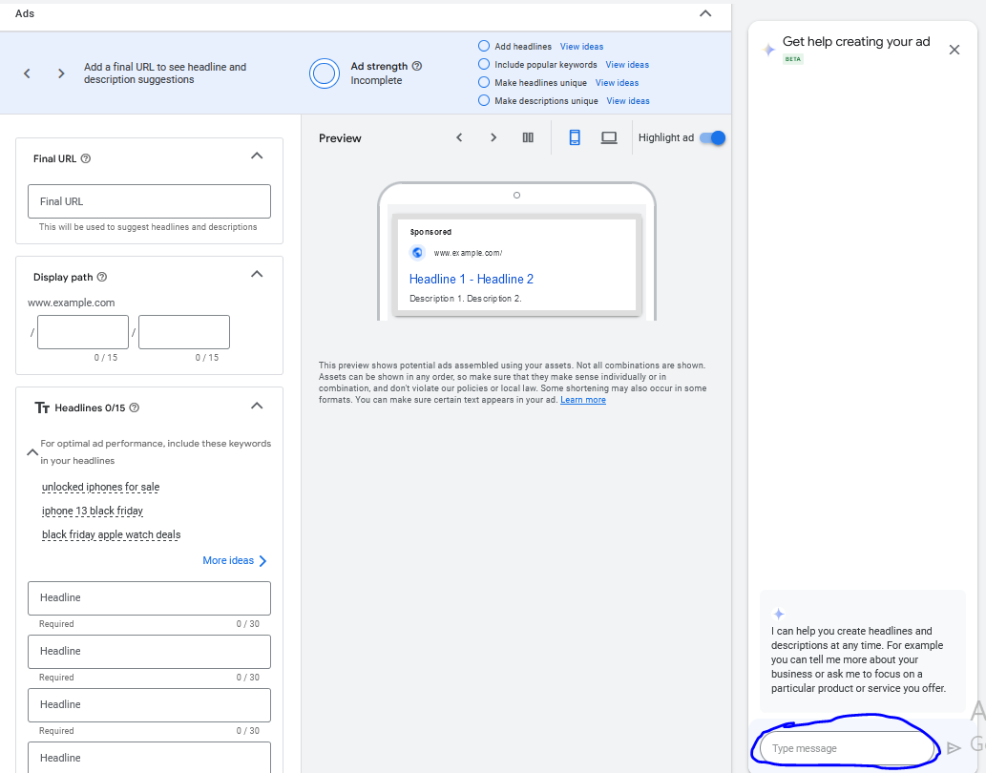So there is a functionality of the AI in marked above

Now type about your business there and get the idea

We type that “my website name is shoponlinehub.in and I sell apple products specially iphones“

You don’t have to tell that you need to generate headlines , description It tell you yourself

In other tools you have to tell it

It may ask youb some question

ATT (According to Teacher)

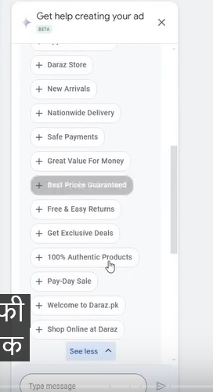

Threre are few suggestion in the headlines given to us

Not all will be goog but you will get many good headline are description

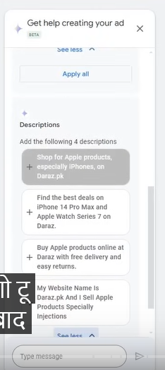

You can see the description above

Whateer description od heading you choose will be added to our ad

Or you can also use Chatgpt by teeling it about your business or services and the offer you are giving in your ad

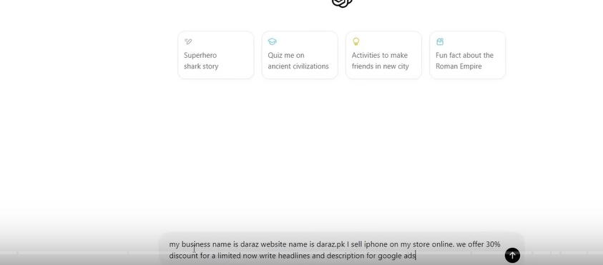

You can see in above

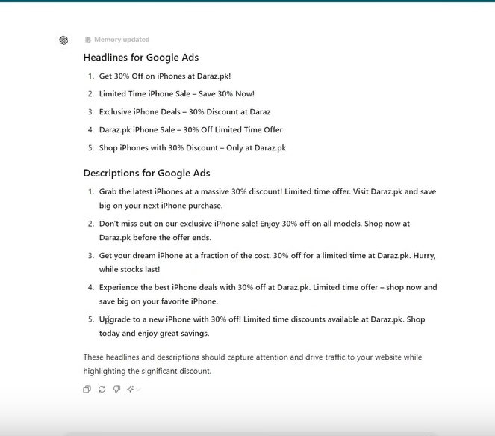

You can also make them shorter by giving them prompt

You can even modify them by typing the prompt

You can also add emotional trigger by prompoting as shown below

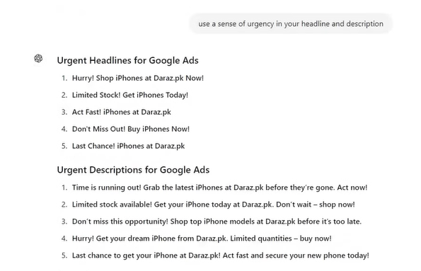

You can also add sense of curiosity in our tips for ad copies as shown below as mentioned

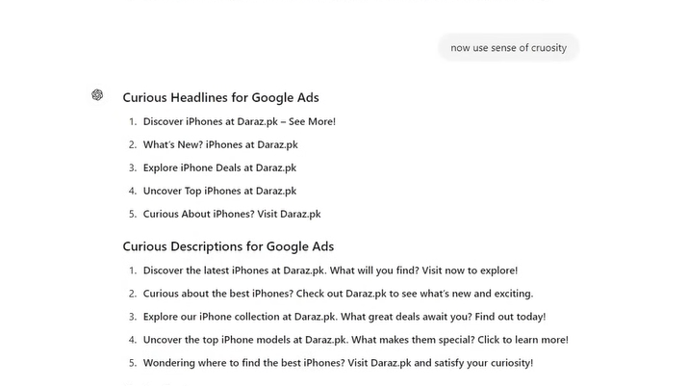

SO first tell about your business in AI

And then tell them that you want headlines or description in your website

If it is giving more character then give prompt to reduce character

Now our almost requirement is fullfilled

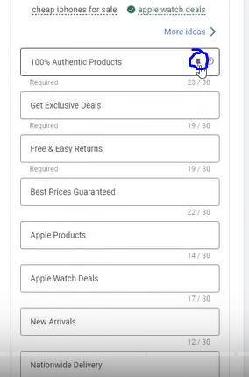

When you hover over any heading and then you hover over the marked icon

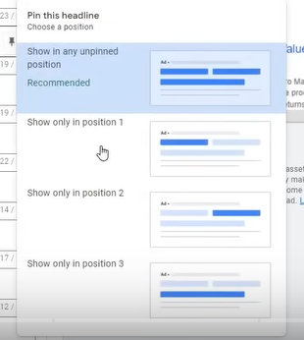

Then you will see the above option

In above you see the option whether to show the headlines in position 1,2 or 3

Now here we are talking about important thing

In position you need to keep keyword

In position 2 keep benefit , unique selling proposition or any offer

In position 3 you need to add your call to action

It meaning you can understand from above

Normally you are allowed only 3 to be visible(whi knows)

You can also do for description also

Make sure it make sense even id you are eversin or not following position rule which we tough you above

If it does not make sense then use random (maybe joking(whi knows))

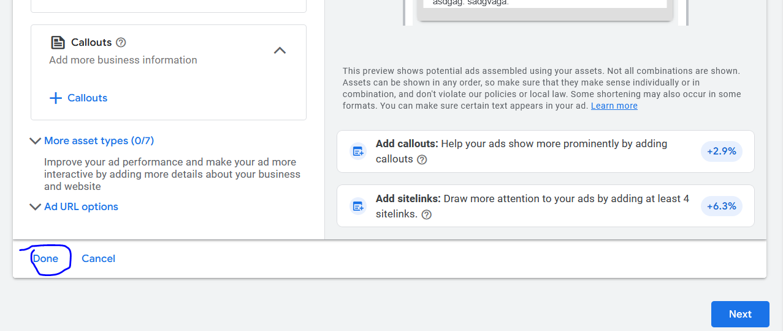

Click on done button as marked above

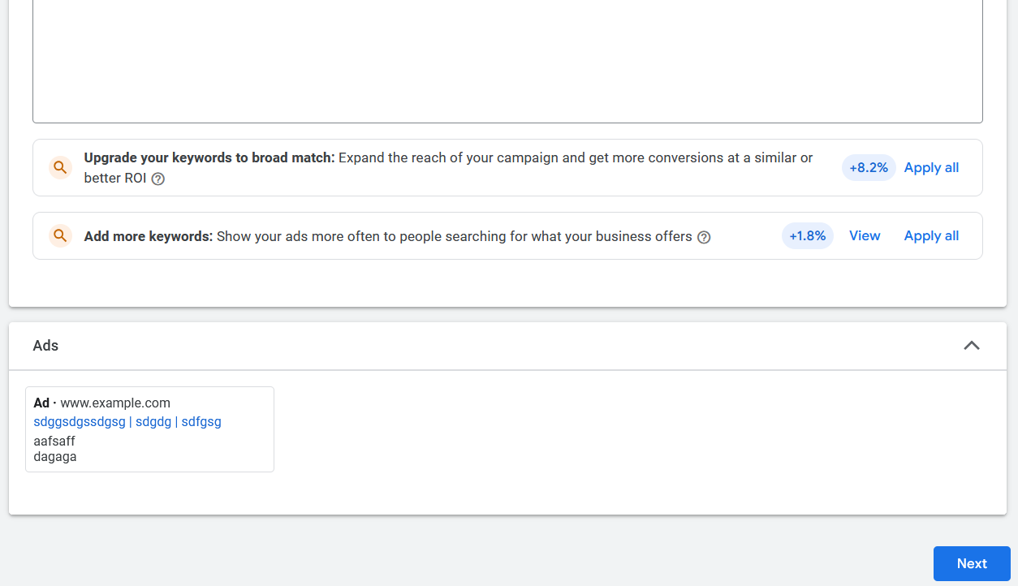

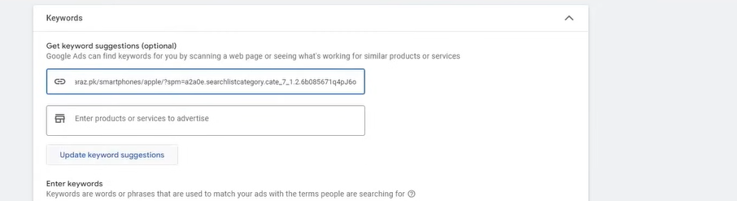

Now in field 1 enter url of the website whose keywords we want to find

Now after entering url now click on Update Keyword Suggestion

NOw the below text area will be upadated with the suggestion so keep a backup of the manual suggestion

Now click on next button